

**USER MANUAL SIGN-OFF**

**Authorization Memorandum**

This form is to sign-off completion of the Design Phase for **CAMPUS MANAGEMENT SOFTWARE AT WORLD SKILL CENTER (WSC).**

World Skill Centre (WSC) acknowledges receipt of the User Manual deliverable through the submission of this document.

|  |  |
| --- | --- |
| **MODULE NAME** | **Examination** |
| **MODULE OWNER** | **Mr. Suresh Kumar** |

**WSC AUTHORITY NAME AND SIGNATURE**

**SOUL AUTHORITY NAME AND SIGNATURE**

 



**Sustainable Outreach And Universal**

**Leadership (SOUL) Limited**

**User Manual**

Of

**Examination**

For Implementation of

**Campus Management Software**

at

**World Skill Center (WSC)**

**Confidentiality**

This document is a strictly confidential communication to and solely for the use of the recipient and may not be reproduced or circulated without SOUL Ltd’s prior written consent. If you are not the intended recipient, you may not disclose or use the information in this documentation in any way

**Document Control History**

|  |  |  |  |  |
| --- | --- | --- | --- | --- |
| **Date** | **Version No.** | **Created By** | **Affected Sections** | **Reviewed By** |
| 16-10-2023 | 1.0 | Subhodeep Dey |  |  |
|  |  |  |  |  |
|  |  |  |  |  |

Table Of Contents

1 Introduction 4

1.1 Background 5

1.2 Scope and Purpose of the document 5

2 General Procedures 6

2.1 General Procedures for a Save Screen 6

2.1.1 Create of New document 6

2.1.2 View a Saved Document 7

2.1.3 Delete a Saved Document 8

2.1.4 Rename a Saved Document 8

2.1.5 Print a Saved Document type 9

2.1.6 View the saved document in different format. 10

2.1.7 View the saved documents by applying filters. 11

2.2 General Procedure for a Submittable Screen 14

2.2.1 Create of New document 14

2.2.2 Cancel a Submitted Document 15

2.2.3 Amend a Submittable Document 16

2.2.4 Delete a Submittable Document 17

2.2.5 Action Menu on a document. 18

3 Examination Master 19

3.1 Exam Type 19

3.2 Assessment Component 21

3.3 Grading Scale 22

4 Examination 24

4.1 Exam Declaration 24

4.2 Module Wise Exam Group 25

4.3 Exam Evaluation Plan 27

4.4 Exam Paper Setting 29

4.5 Student Backpaper Tracking 31

5 Tools 32

5.1 Component Wise Evaluation Tool 32

5.2 Component Wise Reevaluation Tool 34

5.3 Cumulative Marksheet Tool 36

5.4 Final Semester Result Tool 37

6 Evaluation 39

6.1 Component Wise Evaluation 39

6.2 Component Wise Reevaluation 41

6.3 Final Semester Result 42

7 Reports 44

7.1 Final Semester Result Report 44

7.2 Course Wise Performance 45

7.3 Module Wise Performance 47

8 Transcripts 48

8.1 Cumulative Marksheet 48

9 Security: User access and authorization 50

# Introduction

The World Skill Center (WSC) is a premier advanced skill training institute established by the Government of Odisha, Skill Development and Technical Education Department, through the Odisha Skill Development Authority (OSDA). The WSC will impart advanced skill training in eight trades from engineering and service sectors. WSC caters primarily to induct the best talent from ITIs and Polytechnics and training them to become globally employable in emerging areas such as "Industry 4.0". WSC is housed in a state-of-the-art, 18-storey, air-conditioned building with nearly half a million square feet of space in the heart of capital city of Bhubaneswar.

With the implementation of campus management software for WSC the goal is to streamline the operations and functions of the campus by integrating various processes, such as admissions, course registration, academic progress tracking, and financial management, HRMS, Procurement and Inventory management, etc into a unified system. The implementation also aims at providing a user-friendly interface for all stakeholders, making it easier for them to access the necessary information and complete their tasks with ease. The modules to be covered during the implementation of the software include:

|  |  |
| --- | --- |
| Students Management Modules | Infrastructure Management |
| Academic System | Finance and Accounting System |
| Procurement & Inventory Management | Training and Placement |
| Human Resources Management System | Application Integration |

# 

## Background

The Web Based Campus Management Application at World Skill Centre (WSC) application is required by WSC for the smooth operation of all departments / support functions with on-line delivery of services to all stakeholders.

The project aims to create a mechanism to provide the basis for evolution of an IT enabled state of the art workflow automation system in a planned manner.

## Scope and Purpose of the document

The design documents track the necessary information required to effectively define architecture and system design in order to give the development team guidance on the architecture of the system to be developed. Its intended audience is the project manager, project team, and development team. Some portions of this document, such as the user interface (UI), may be shared with the client/user, and other stakeholders whose input/approval into the UI is needed.

This document covers all the functional requirements of the **Examination module** of ERP Product. The ERP Examination module helps in organizing the entire education set-up, such as Student Database, Fee Structure, Trainer Information Assessment and Result Declaration and Cumulative Marksheet, Certificate Generation, etc.

The scope of Training and Placement module

* Courses and Subjects, Timetable preparation and management  ▪
* Class occurrence monitoring
* Class Attendance of students (Face recognition or any other automated mode).    ▪
* Results Analysis after declaration of results by WSC ▪
* Students Feedback mechanism on quality of teaching learning ▪ Internship, Training, Apprentice ▪
* Re-Admission Process after discontinuing in studies ▪
* Students Back paper tracking etc.
* Student Profile :Personal Information, Contact Details, Academic Details ▪
* Issue of Identity Card.  ▪
* Student Profile: Personal Information, Contact Details, Academic Details.
* Re-Admission Process after discontinuing in studies
* Issue of Identity Card
* Faculty Workload / Lesson Plan
* Rewards and achievements. 
* Biometric Attendance (Face recognition) ▪
* Hostel Management (Hostel seat allotment, attendance, fees etc) ▪
* Scholarships.  ▪
* Rewards and achievements.  ▪
* Students’ Evaluation/remarks of Faculty.  ▪
* Student Exams records of all 6 semesters ▪
* Parent Enquiry/Alert/Messaging Management.  ▪
* Messaging System  ▪
* Student Grievance System etc.

# General Procedures

## General Procedures for a Save Screen

### Create of New document

* Login in to the system
* Go the required workspace

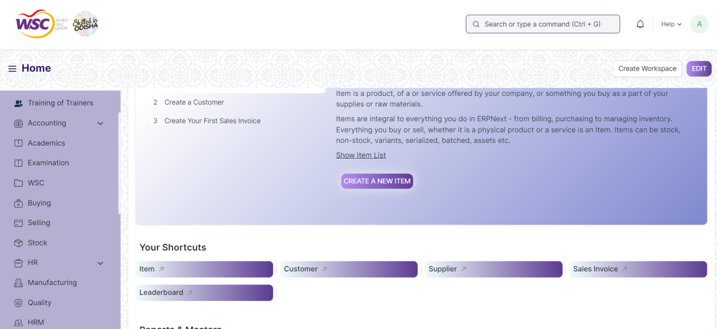

* Go to the required screen.
* Click on the ***“+Add Screen Name”*** button in the right corner of the screen.

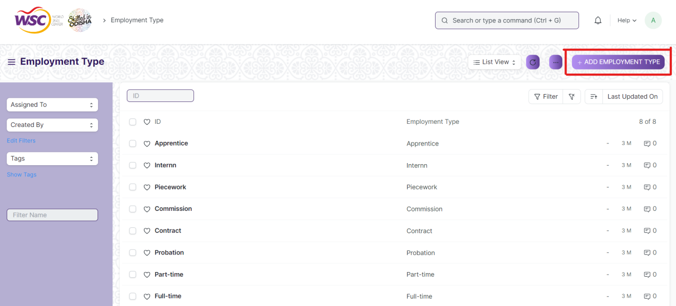

(Example : For addition in the new Employment Type , click +Add Employment Type button).

* Enter the required data.
* Click on “***Save”*.**
* After saving , the record will be visible in the List View of the screen.

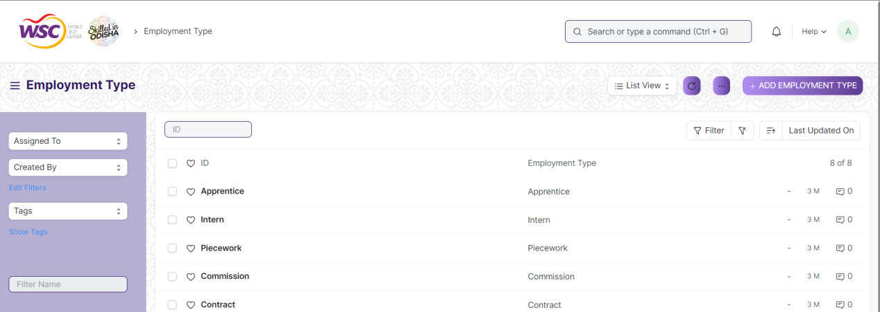

(Example : List view of saved Employment Types)

**Note :** The process of creation can only be carried out by employees who have necessary permission.Kindly refer to the Screen wise permission section in the document.

### View a Saved Document

* Log in to the system.
* Go to the required workspace
* Go to the required screen.
* Click on the required document from the list view of the screen.

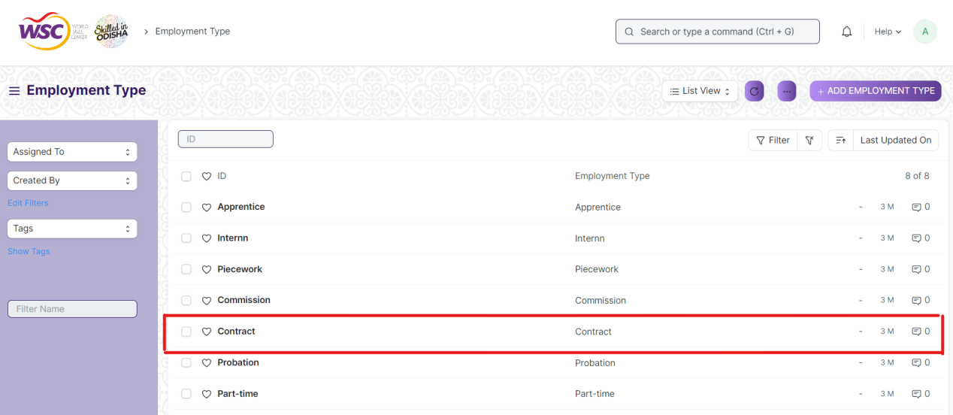

(Example : View of “Contract” Document of Employment Type Screen)

View the clicked document.

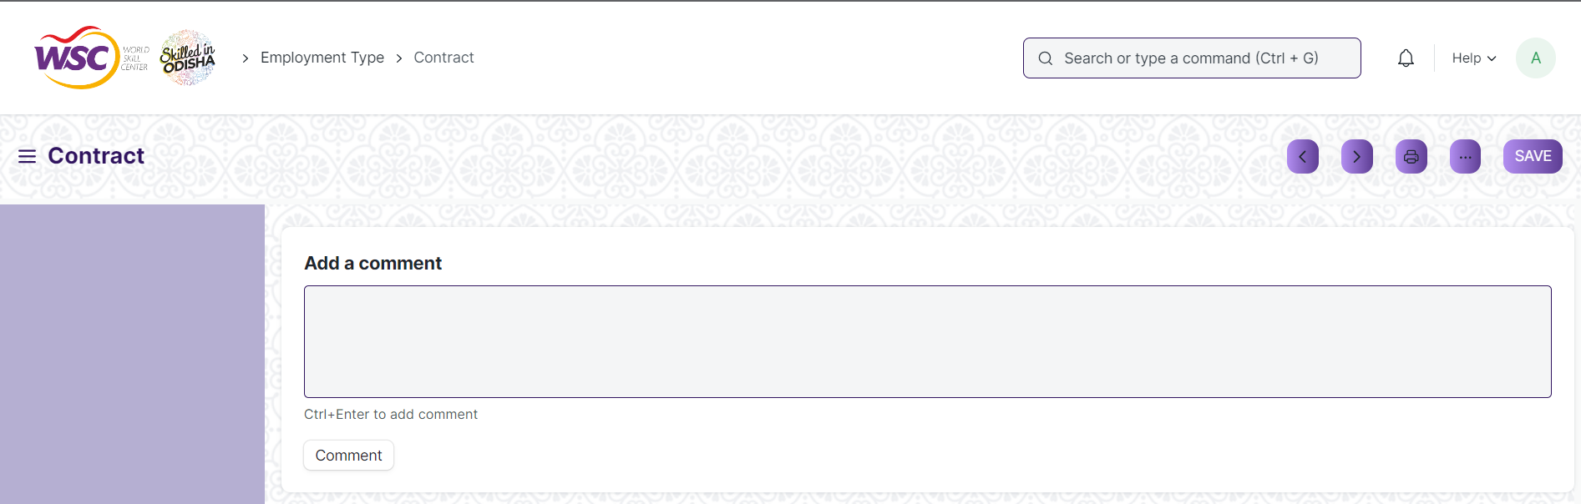

(Example : View of the “Contract” Employment Type)

**Note :** The process of view can only be carried out by employees who have necessary permission.Kindly refer to the Screen wise permission section in the document.

### Delete a Saved Document

* Log in to the system
* Go to the required workspace
* Go to the required screen.
* Click on the required document from the list view of the screen.
* Click on the 3 dots in the right corner of the screen.
* Click on *“****Delete”*.**

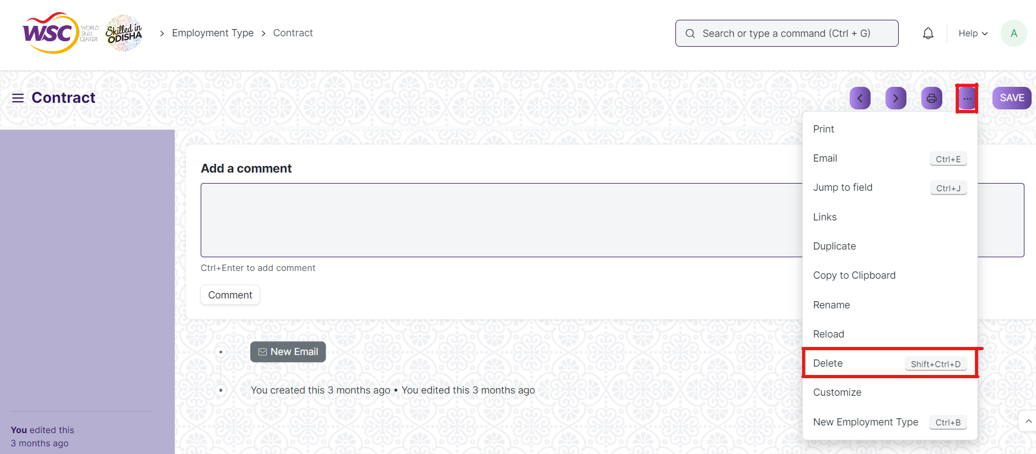

(Example : Deletion of “Contract” document of Employment Type)

Click yes if you want to delete the selected document.

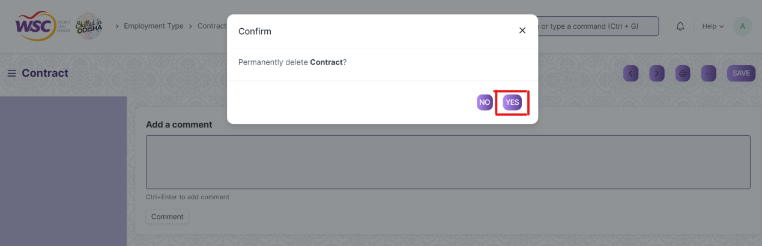

(Example : Clicking Yes to Delete permanently the document)

**Note :** The process of deletion can only be carried out by employees who have necessary permission.Kindly refer to the Screen wise permission section in the document.

### Rename a Saved Document

* Login to the screen.
* Go to the required workspace
* Go to the required screen.
* Click on the required document from the list view of the screen.
* Click on the 3 dots in the right corner of the screen.
* Click on *“****RENAME”*** .

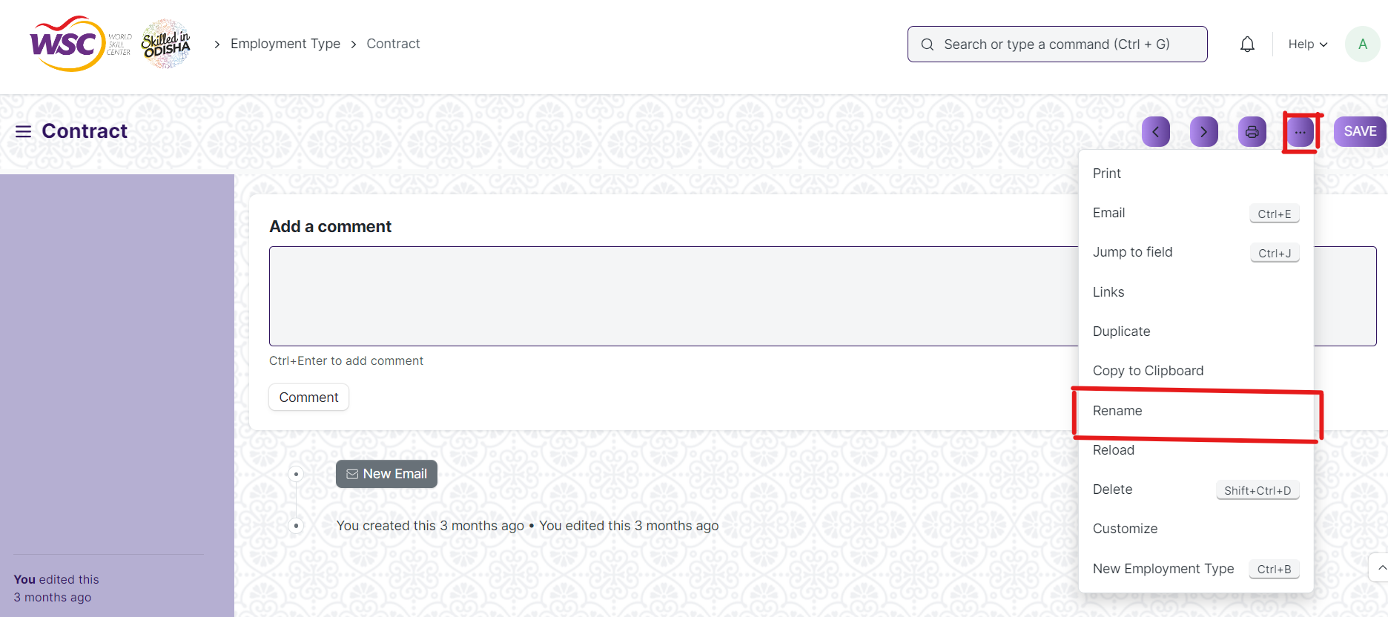

Click on *“****Rename”*** button to rename the document.

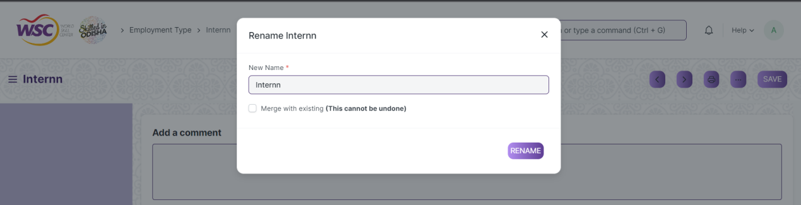

**Note :** The process of deletion can only be carried out by employees who have necessary permission.Kindly refer to the Screen wise permission section in the document.

### Print a Saved Document type

* Login to the system
* Go to the required workspace
* Go to the required screen.
* Click on a saved document in the screen.
* Click on the print button present in the right corner of the screen.

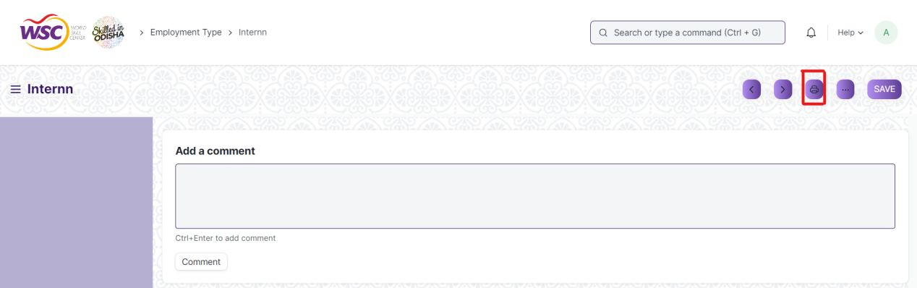

A new screen will open.

Click on the print button to Print the document.

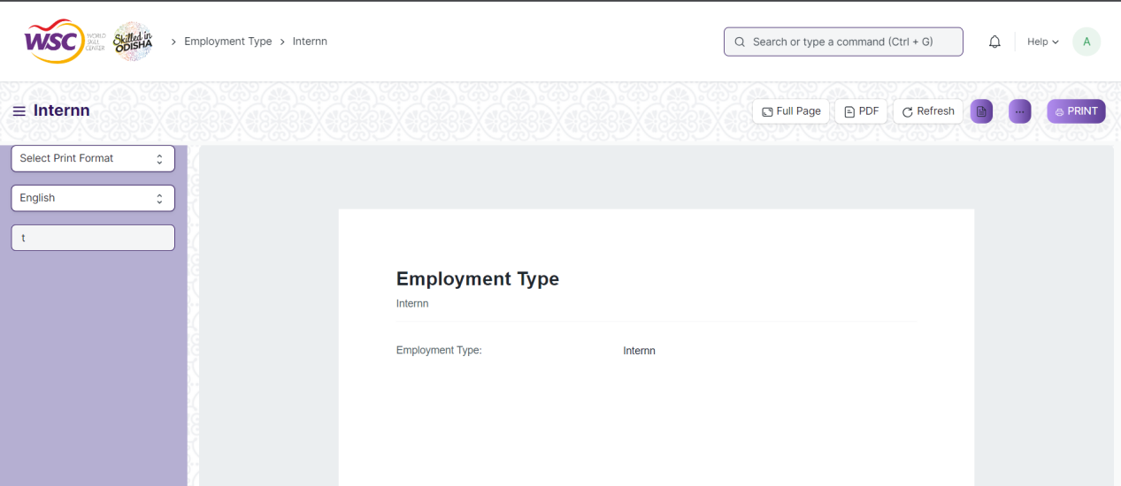

To download the employment type as PDF , click on the PDF button .

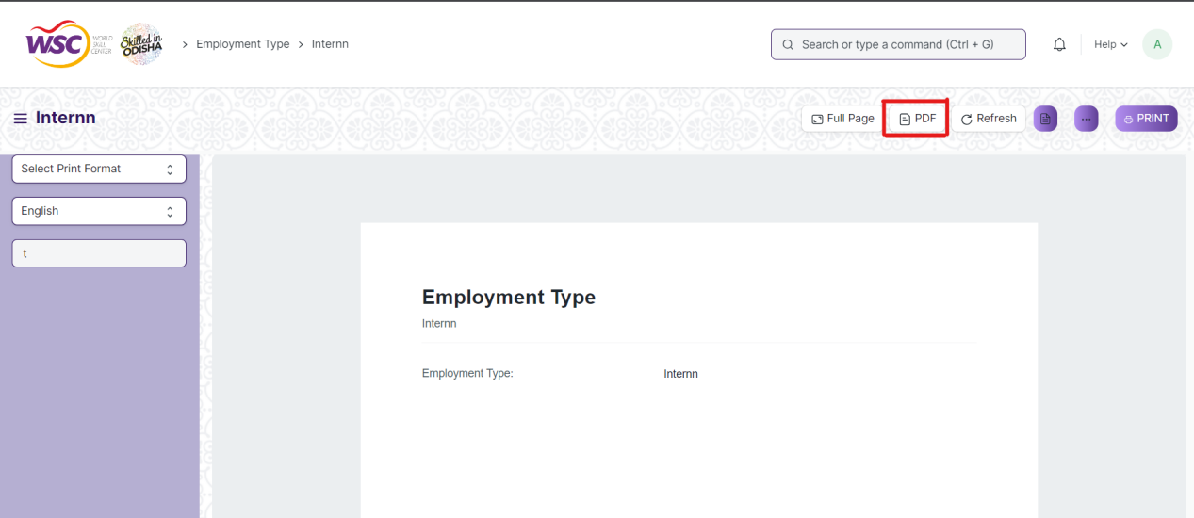

**Note :** The process of printing can only be carried out by employees who have the necessary permission.

### View the saved document in different format.

* Login to the system
* Go to the required workspace
* Go to the required screen.
* Click on the List View Button in the screen.

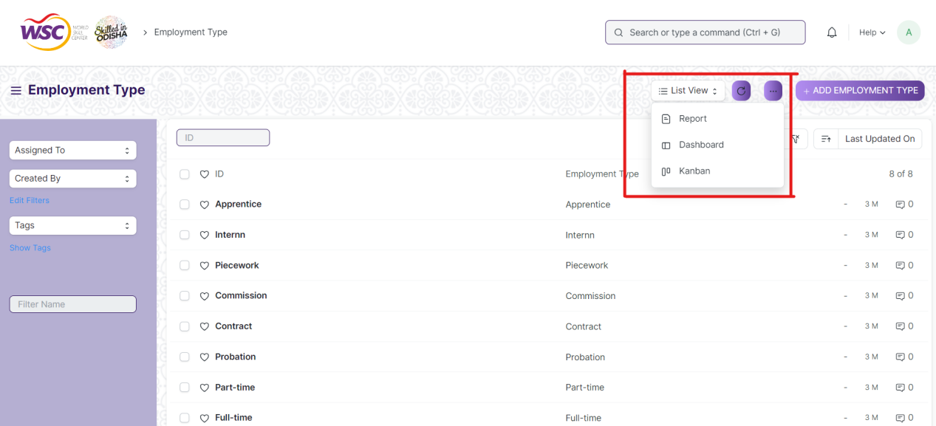

Select the appropriate view type that you want.

**Note :** The List view button can only be showed to the employees who have necessary permission.

### View the saved documents by applying filters.

* Login to the screen.
* Go to the required workspace.
* Go to the required screen.
* Click on the ***“Filter”***.

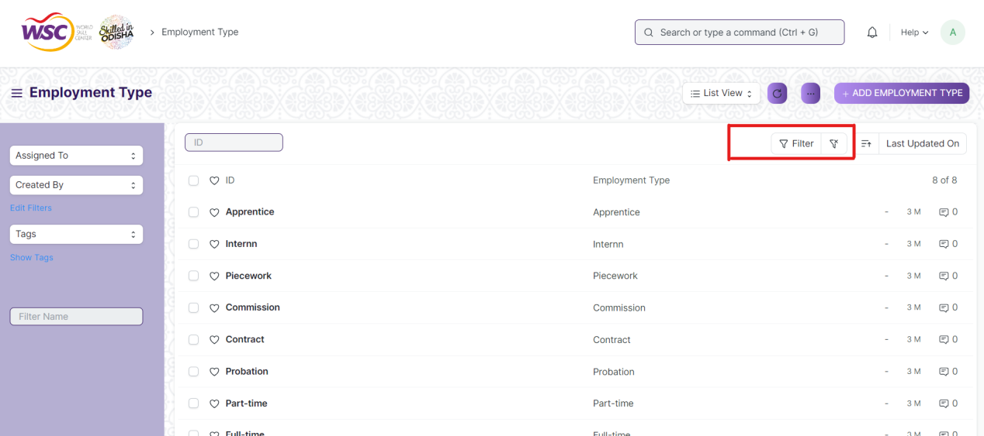

* Select the field of the document based on which you wish to filter the records. All the fields in a form will be selectable in this list.

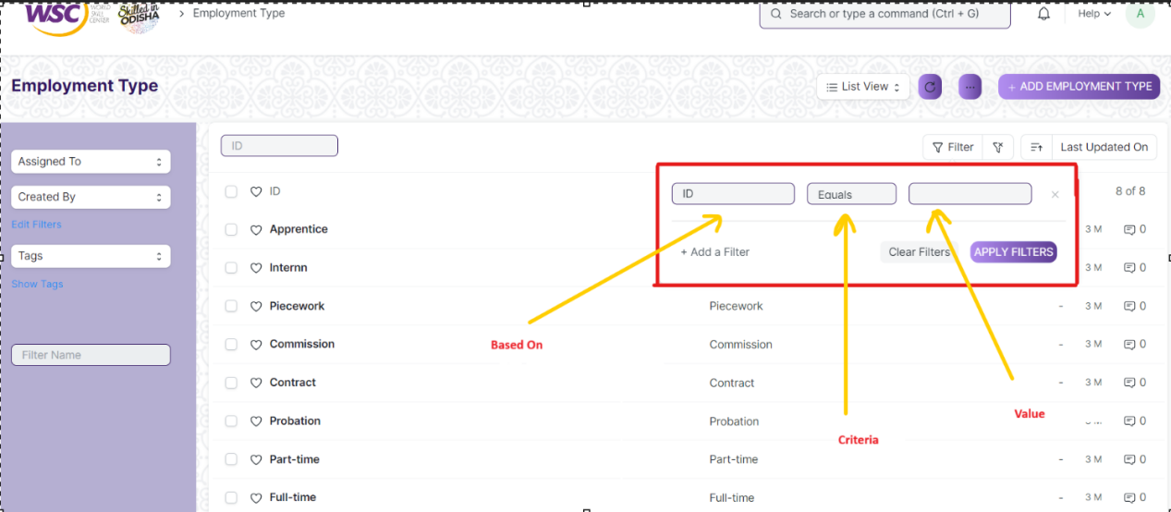

**Based On :** For the field, you will be required to put a value of the field. In the 'based on' field.

**Criteria :** You can define criteria based on which the system will search the document.The different conditions on which the filters are based are: Equals, Not Equal, Like, Not Like, In, Not In, =,>,< etc.

**Value :** Here, you will be required to enter the value for which you are running the document search.

**Some Examples of Viewing the documents in the list view after applying filters.**

Filter on Employee screen where Gender Equals to Male. After clicking the Apply Filter button, all the filtered document will show in the screen.

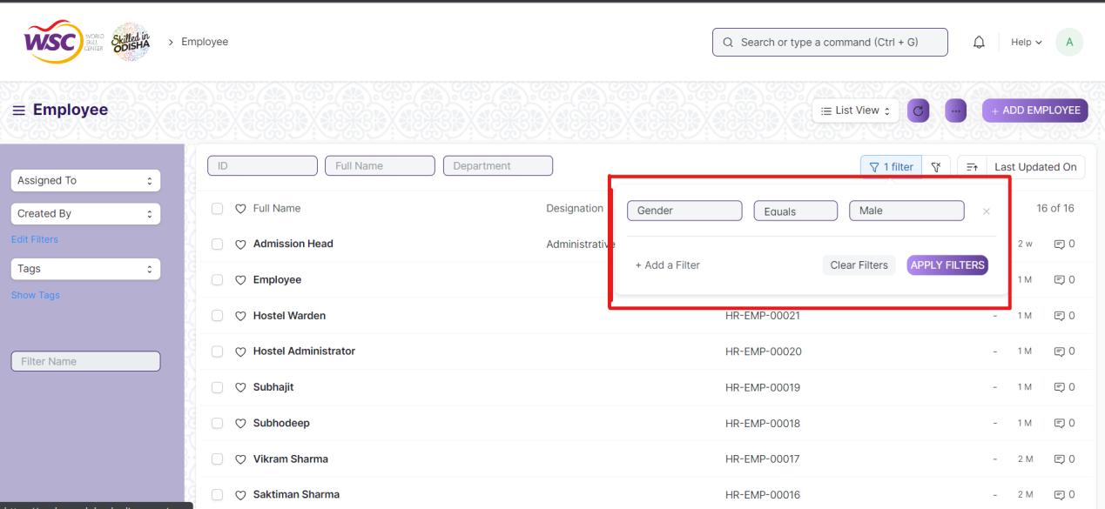

Filter on Employee Screen where, the full name starts with ‘A’.

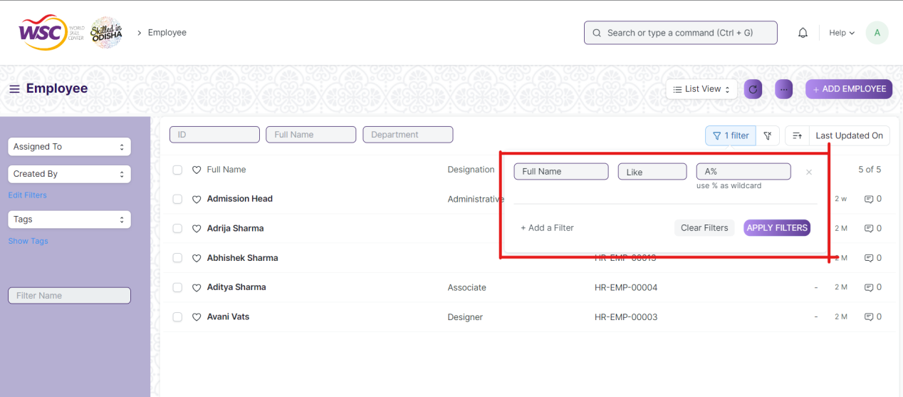

Filter on Employee Screen , where Date of Joining is greater than a particular date.

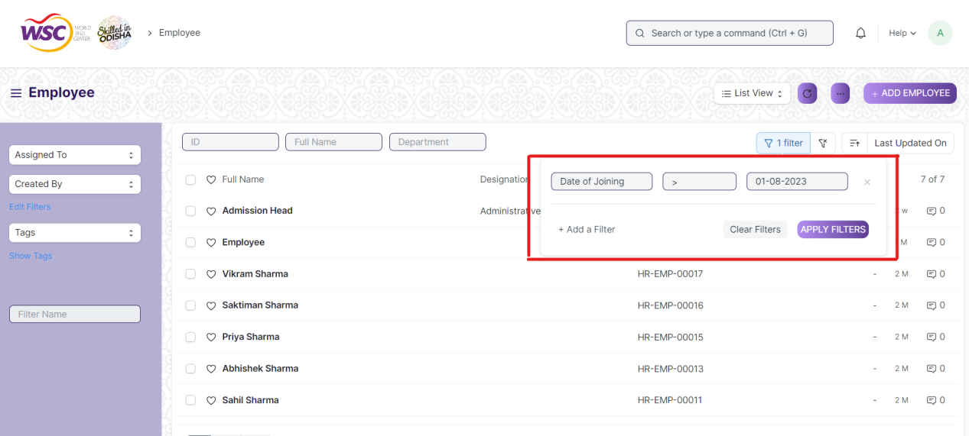

You can also apply multiple filters at a time. To remove a specific filter, just click on 'x' sign on it. To add another filter Click on the +Add a Filter button.

**Example of Multiple filter .**

Applying filter in the employee screen , where date of joining is greater than some date and gender is equal to Male.

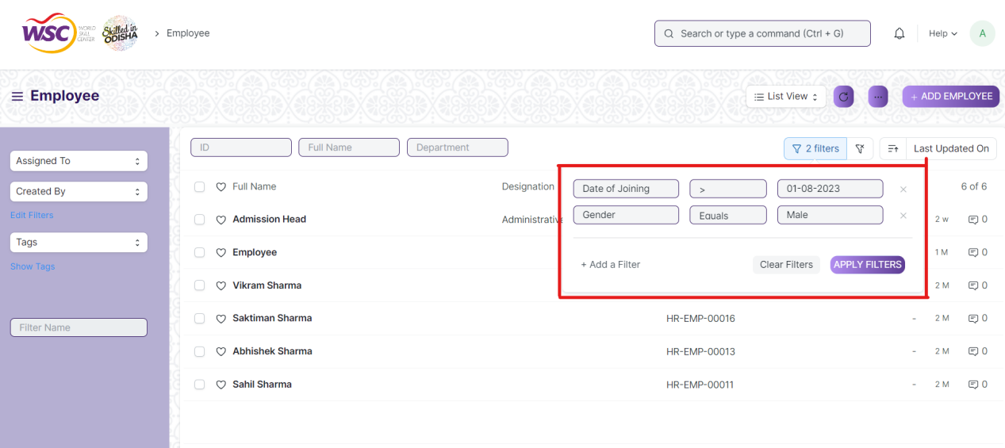

**Default Filters**

There are some filters present out of the box for the views which can be used for filtering the search results.

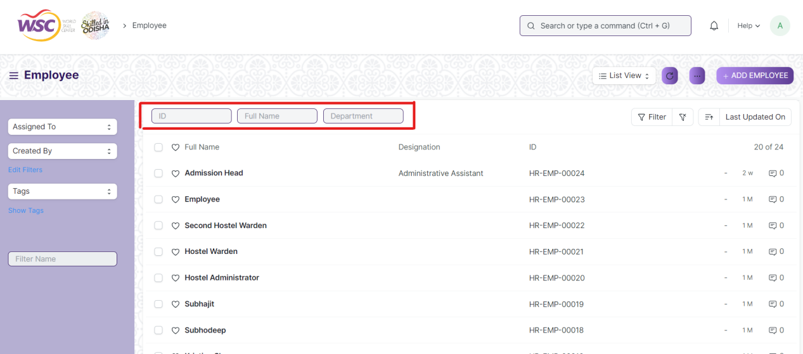

**Note :** The Filter Option can only be showed to the employees who have necessary permission.

## General Procedure for a Submittable Screen

### Create of New document

* Login in to the system
* Go the required workspace
* Go to the required screen.
* Click on the ***“+Add Screen Name”*** button in the right corner of the screen.

(Example : For addition in the new Employment Type , click +Add Employment Type button).

* Enter the required information in the document.
* Once you are finished entering the information , click the ***“Save”*** button.
* After saving it , a submit button will appear.

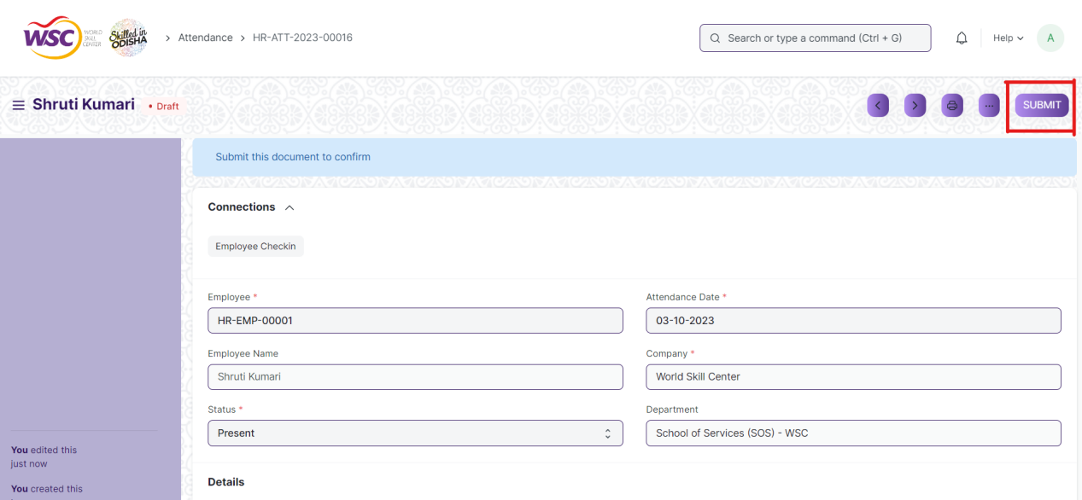

Click on the **“Submit”** button.

A confirmation dialog box will appear . Click the Yes button to submit the document.

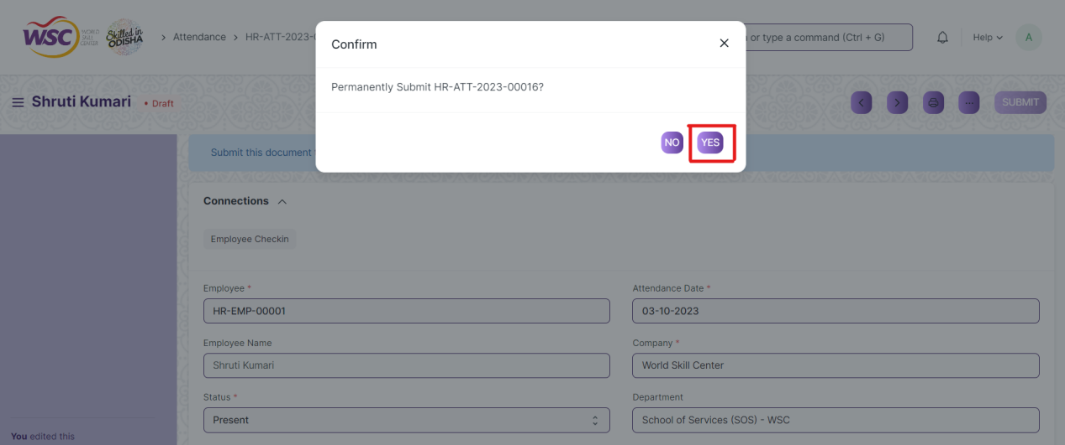

After submitting , the record will be visible in the List View of the screen.

**Note :** The process of creation can only be carried out by employees who have necessary permission.Kindly refer to the Screen wise permission section in the document.

### Cancel a Submitted Document

* Log in to the system.
* Go to the required workspace
* Go to the required screen.
* Click on the required document from the list view of the screen.
* Click the ***“Cancel”*** Button .

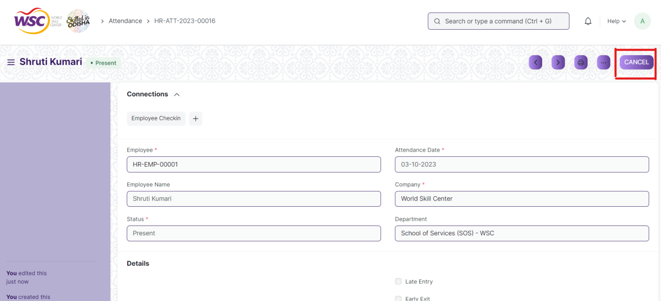

A confirmation dialog box will appear . Click the Yes button to cancel the document.

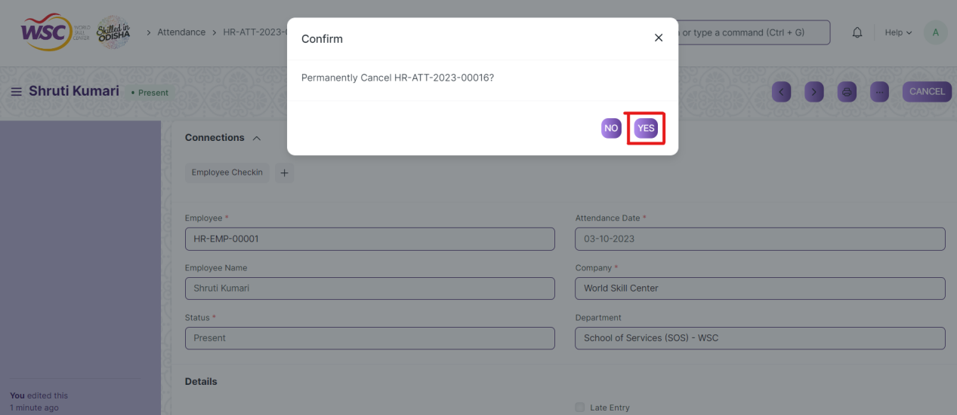

**Note :** The process of cancellation can only be carried out by employees who have necessary permission.Kindly refer to the Screen wise permission section in the document.

### Amend a Submittable Document

* Log in to the system.
* Go to the required workspace
* Go to the required screen.
* Click on the required document from the list view of the screen.
* After cancellation of the document , an Amend button will appear on the screen.

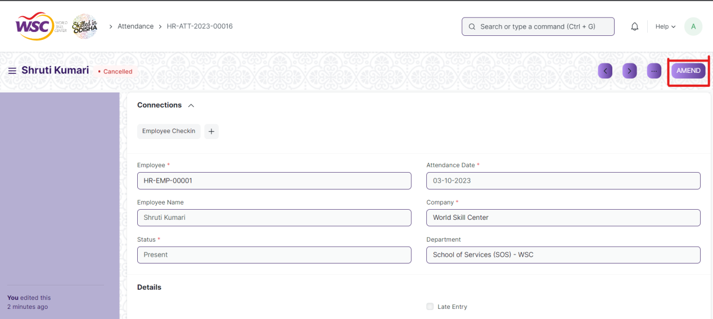

Click the “***Amend”*** button.

A new document will be created with the same information as the original document .

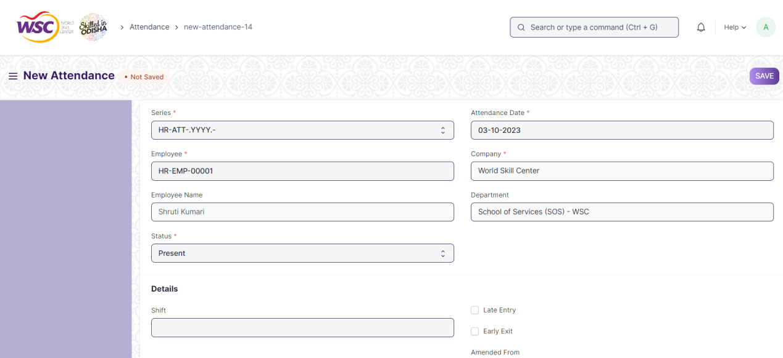

You can now make changes to the document as needed.

**Note :** The process of Amend can only be carried out by employees who have necessary permission.Kindly refer to the Screen wise permission section in the document.

### Delete a Submittable Document

* Log in to the system.
* Go to the required workspace
* Go to the required screen.
* Click on the required document from the list view of the screen.
* If the document is in draft sate , you can follow the procedure to delete a save document .
* If the document is submitted , then cancel it first , then delete it.

After cancellation of the document , an Amend button will appear on the screen.

**Note :** If the document you are deleting is linked with any other document , then cancel the dependent document  first , then try to delete it.

Example :

In the Attendance Request Screen, when an attendance request  record is Approved , then a record in the attendance screen will be created.  it is not allowed for deletion of the attendance request record until the associated attendance record is canceled or deleted.

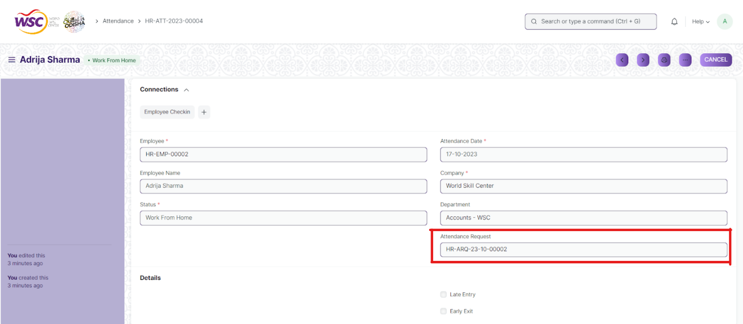

(Attendance Request  Record **HR-ARQ-23-10-00002** linked with Attendance **HR-ATT-2023-0004** )

On deletion of attendance request record  ,It will show the following message ,

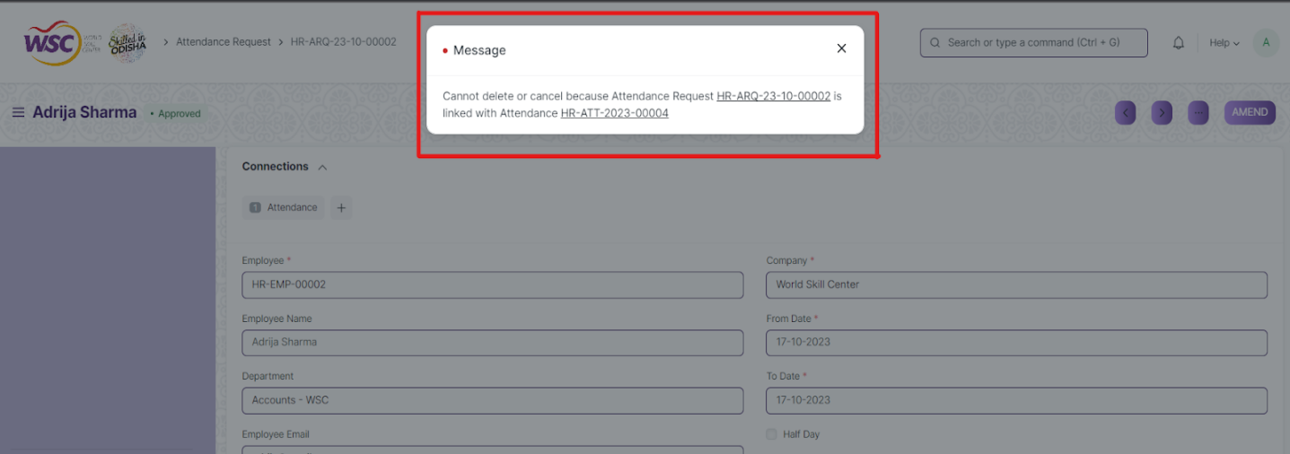

So go the following Attendance Request record document(**HR-ARQ-23-10-00002 )**, and cancel it first . After cancellation , user will able to delete the attendance record ( **HR-ATT-2023-0004)**.

**Note :** To initiate the cancellation process, kindly click on the link labeled **'HR-ARQ-23-10-00002**,' which corresponds to the attendance request record."

### Action Menu on a document.

The three dots menu, located in the right corner of a document in a Screen , offers a range of actions and options to manage and interact with the document.

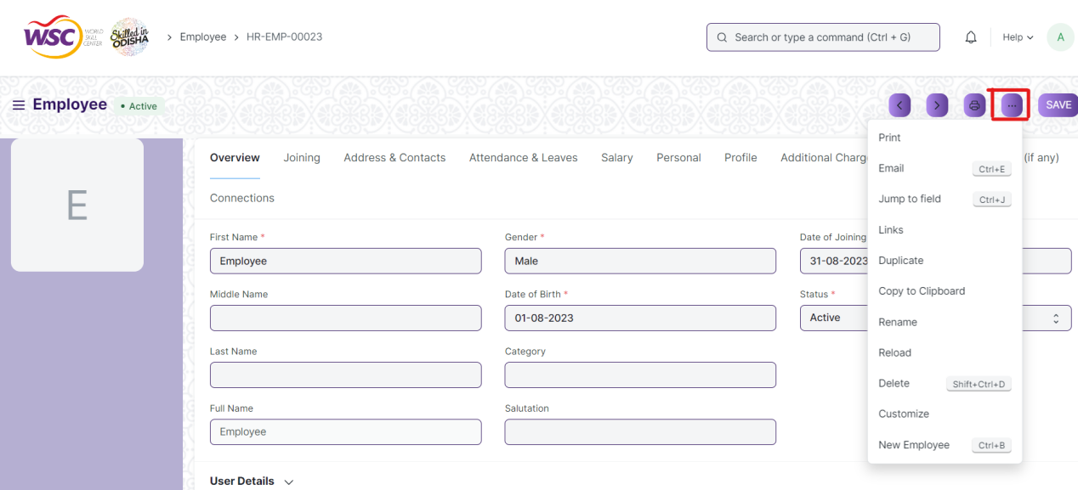

The functionalities available in the three dots menu are given below .

**Print :** Print Enables you to generate a printable version of the document ., which you can save as a PDF or send to a printer.

**Email :** Click on Email allows you to send the document as an attachment via email to specified recipients.

**Duplicate :** Create a new document with the same information as the current one.

**Delete :** Permanently remove the document.

**Cancel :** Cancel the submitted document.

**Submit :** Submit the document . If the document is submittable.

**Links :** This Option displays a list of document that are linked to the current document. You can navigate these linked documents from here.

**Jump to field :** You can directly go the required field by clicking this option and giving appropriate field name.

**Copy to Clipboard :** By clicking this option you can copy the content of the document .

**Rename :** By clicking the Rename option you can Rename the document.

**Note :** These options will be visible to employees who have necessary permission.

# Examination Master

## Exam Type

**Description**

The Exam Type allows user to create and set values for a particular Exam Declaration which shall be beneficial to determine the type of examinations that are being conducted and can be evaluated on the basis of it. For example, an Exam Declaration can be classified as Mid Term Examination or End Term Examination.

The screen is accessible to Exam Administrator, Instructor and Students.

To access the Exam Type Master screen ,go to :

***Home>Examination>Examination Masters>Exam Type***

**Screen**

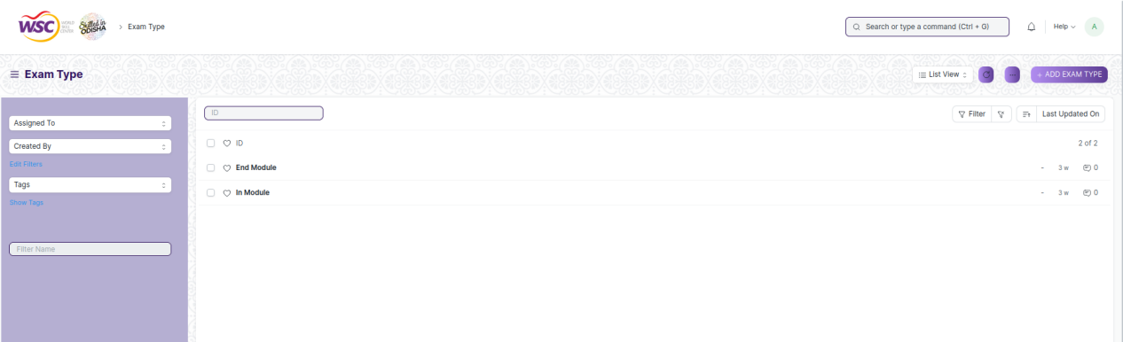

(List view of Exam Type)

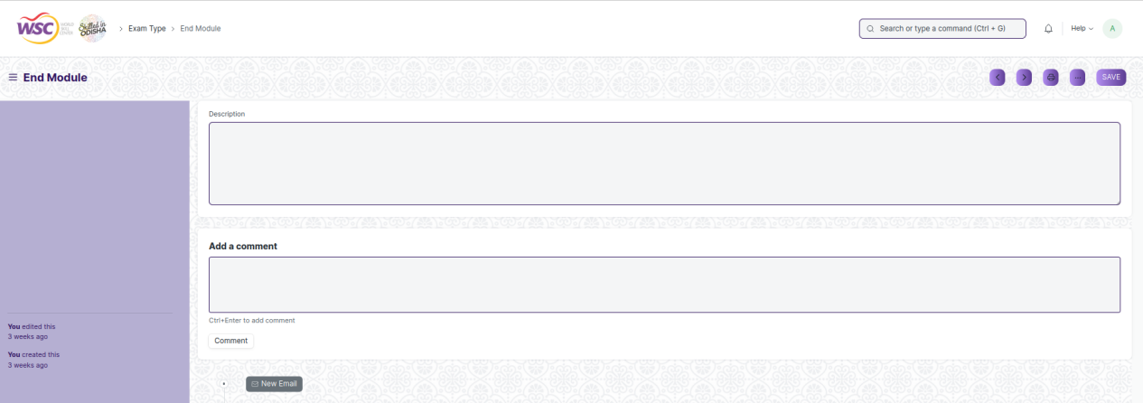

(View a saved record)

**Screen Type**

* Save

**Prerequisites**

* Not Available

**Adding a new record**

As it is a save screen, follow the general procedure to create a save document as mentioned above .

After creating a Exam Type, the record will be visible in the List view of the screen.

**Deleting a record**

As it a Save screen , follow the general procedure to delete a save document .

**Edit Record**

Follow the steps to view a saved Exam Type.

Edit the field that you want to change.

Click on Save.

**Print Record**

As it is a Save screen , follow the general procedure to print a saved document.

**View Record in different format**

As it is a Save screen , follow the general procedure to view a saved document in different format.

## Assessment Component

**Description**

The Assessment Criteria various components of Continuous Evaluation on the basis of which evaluation shall be conducted. Also, multiple Assessment Criteria can be grouped together under Assessment Criteria Group as well as Maximum Credit can be allotted to them. It can also be linked with Exam Declaration if required. For example, Assessment Criteria can be specified as Mid Term, Practical, End Term, Quiz, Viva, etc.

The screen is accessible to Exam Administrator, Instructor and Students.

To access the Assessment Component Master screen ,go to :

***Home>Examination>Examination Masters>Assessment Component***

**Screen**

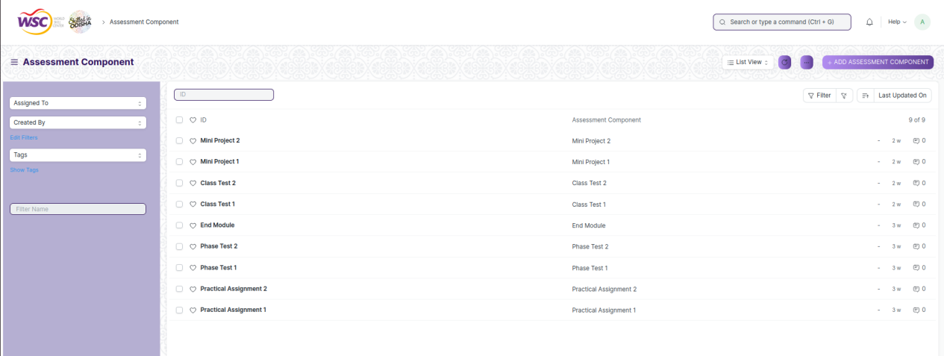

(List view of Assessment Component)

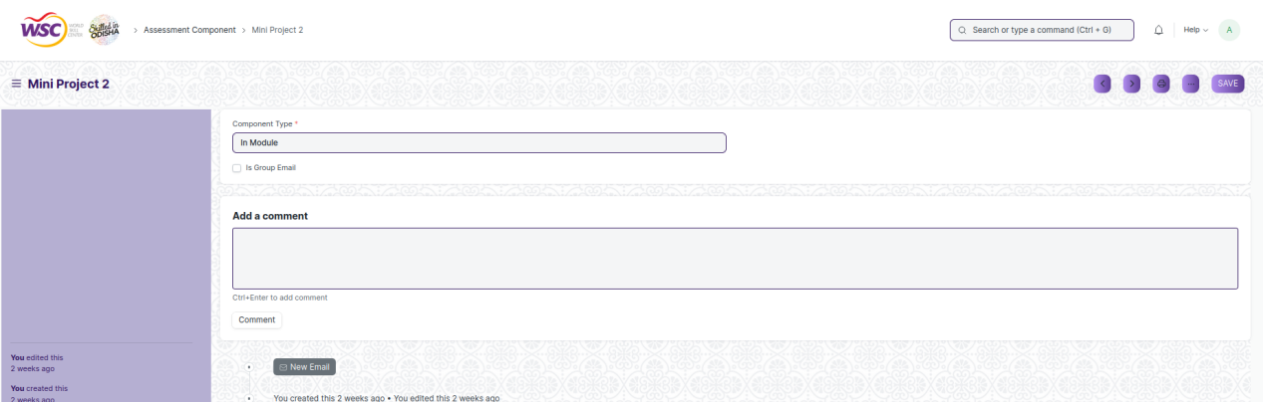

(View a saved record)

**Screen Type**

* Save

**Prerequisites**

* Exam Type

**Adding a new record**

As it is a save screen, follow the general procedure to create a save document as mentioned above .

After creating a Assessment Component, the record will be visible in the List view of the screen.

**Deleting a record**

As it a Save screen , follow the general procedure to delete a save document .

**Edit Record**

Follow the steps to view a saved Assessment Component.

Edit the field that you want to change.

Click on Save.

**Print Record**

As it is a Save screen , follow the general procedure to print a saved document.

**View Record in different format**

As it is a Save screen , follow the general procedure to view a saved document in different format.

## Grading Scale

**Description**

Under Grading Scale, user can define the threshold for the different grades obtained by the students, based on their scores in the assessment. For example, students obtaining a score of 90% and above would be graded as A+, students obtaining a score of 80% and above would be graded A- and so on.

The screen is accessible to Exam Administrator, Instructor and Students.

To access the Grading Scale Master screen ,go to :

***Home>Examination>Examination Masters>Grading Scale***

**Screen**

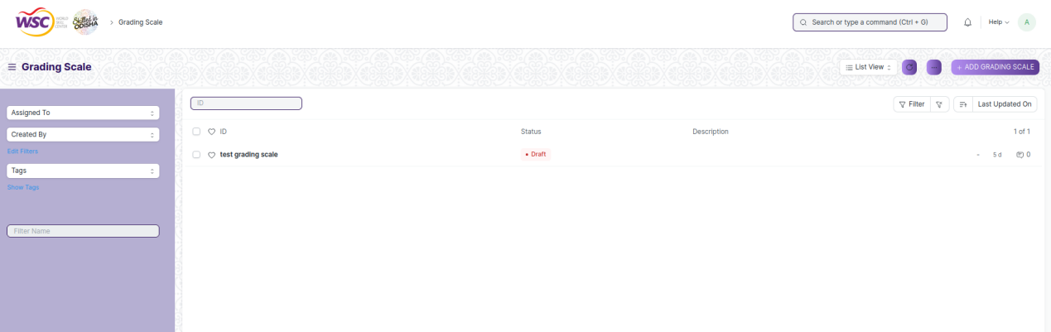

(List view of Grading Scale)

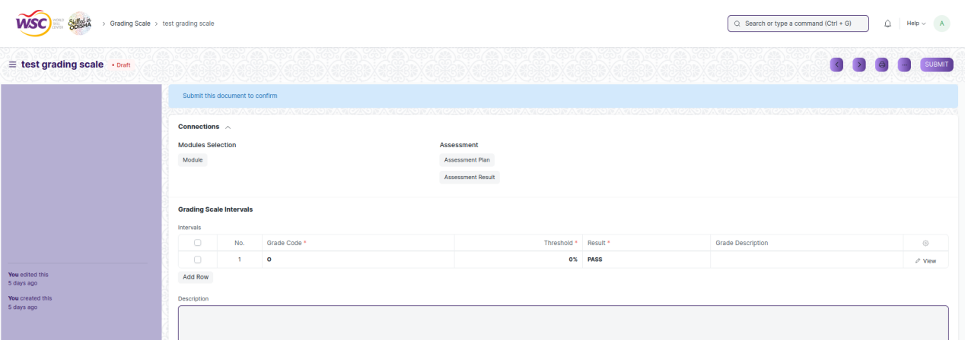

(View a saved record)

**Screen Type**

* Submittable

**Prerequisites**

* Not Available

**Adding a new record**

As it is a submittable screen, follow the general procedure to create a submittable document as mentioned above .

After creating a Grading Scale, the record will be visible in the List view of the screen.

**Deleting a record**

As it a submittable screen , follow the general procedure to delete a submittable document .

**Edit Record**

Follow the steps to view a saved Grading Scale.

Edit the field that you want to change.

If submitted, follow the general procedure to cancel and amend the document.

Click on Save.

**Print Record**

As it is a submittable screen , follow the general procedure to print a submittable document.

**View Record in different format**

As it is a submittable screen , follow the general procedure to view a submittable document in different format.

# Examination

## Exam Declaration

**Description**

The Exam Declaration will allow user to declare an exam for various programs in accordance with the ‘Academic Calendar’ template which was used during the start of each session.

To access the Exam Declaration screen ,go to :

***Home>Examination>Examination>Exam Declaration***

**Screen**

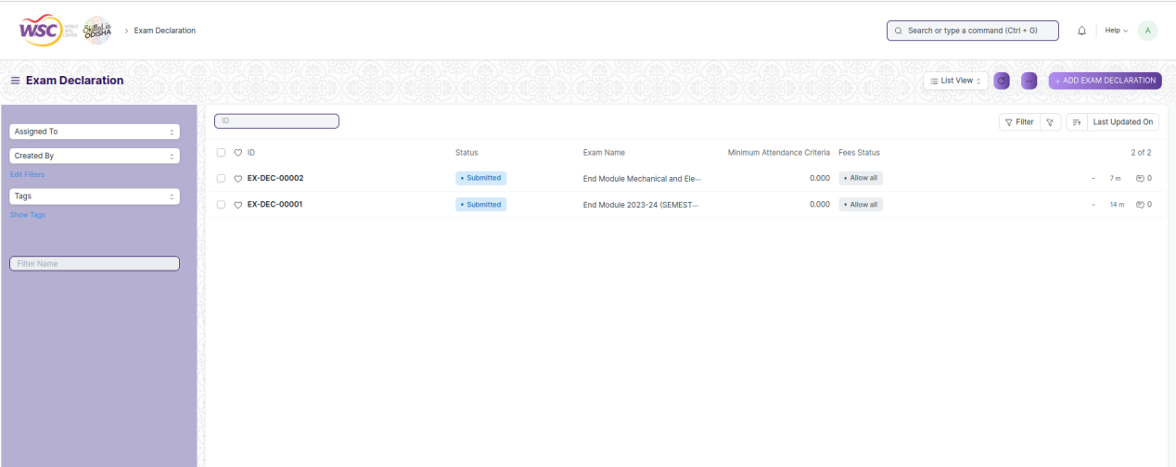

(List view of Exam Declaration)

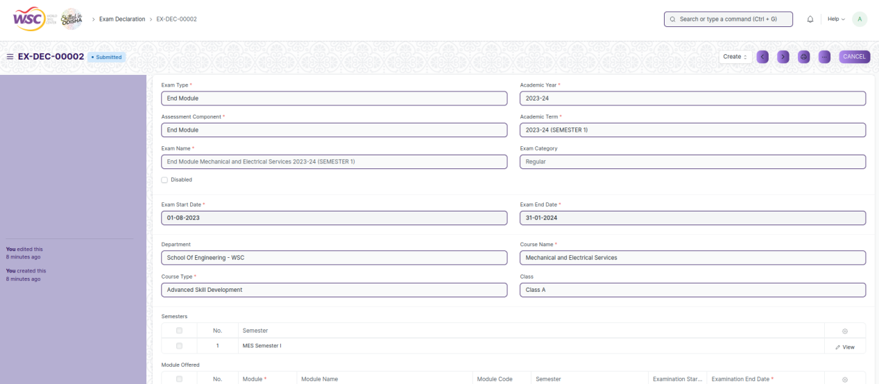

(View a saved record)

**Screen Type**

* Submittable

**Prerequisites**

* Exam Type, Assessment Component

**Adding a new record**

As it is a submittable screen, follow the general procedure to create a submittable document as mentioned above .

After creating a Exam Declaration, the record will be visible in the List view of the screen.

**Deleting a record**

As it a submittable screen , follow the general procedure to delete a submittable document .

**Edit Record**

Follow the steps to view a saved Exam Declaration.

Edit the field that you want to change.

If submitted, follow the general procedure to cancel and amend the document.

Click on Save.

**Print Record**

As it is a submittable screen , follow the general procedure to print a submittable document.

**View Record in different format**

As it is a submittable screen, follow the general procedure to view a submittable document in different format.

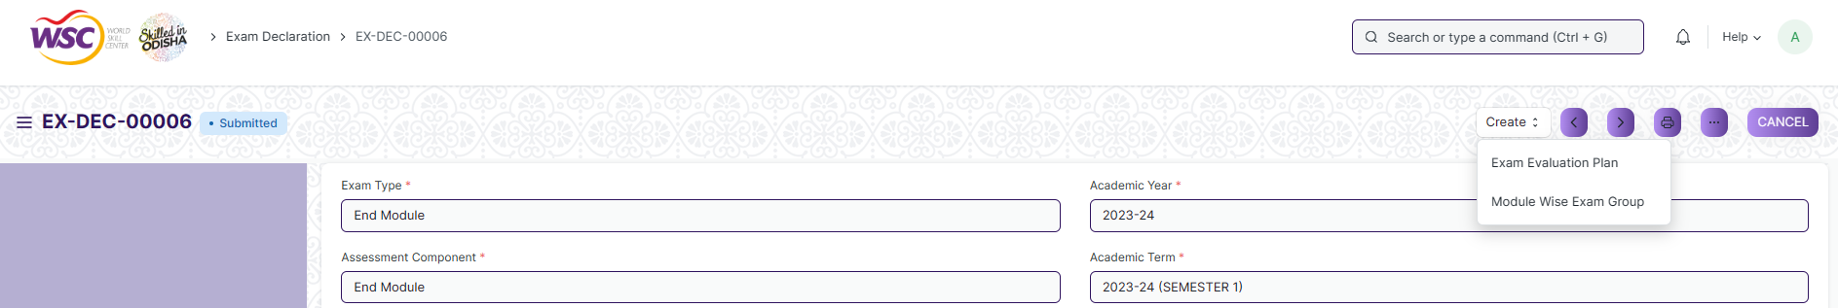

(Buttons)

**Buttons**

The buttons appear after the form is submitted. Under the ‘Create’ button, there are two buttons which are as follows:

1. Exam Evaluation Plan : This button will take the user to the Exam Evaluation Plan screen to create the exam evaluation plan of the current exam declaration form.
2. Module Wise Exam Group: This button will take the user to the Module Wise Exam Group screen to create the exam evaluation plan of the current exam declaration form.

## Module Wise Exam Group

**Description**

With the help of Exam Process Screen, a user can grouped students to giving the exams on the basis of batch, room capacity, lab examination, etc.

To access the Module Wise Exam Group screen ,go to :

***Home>Examination>Examination>Module Wise Exam Group***

**Screen**

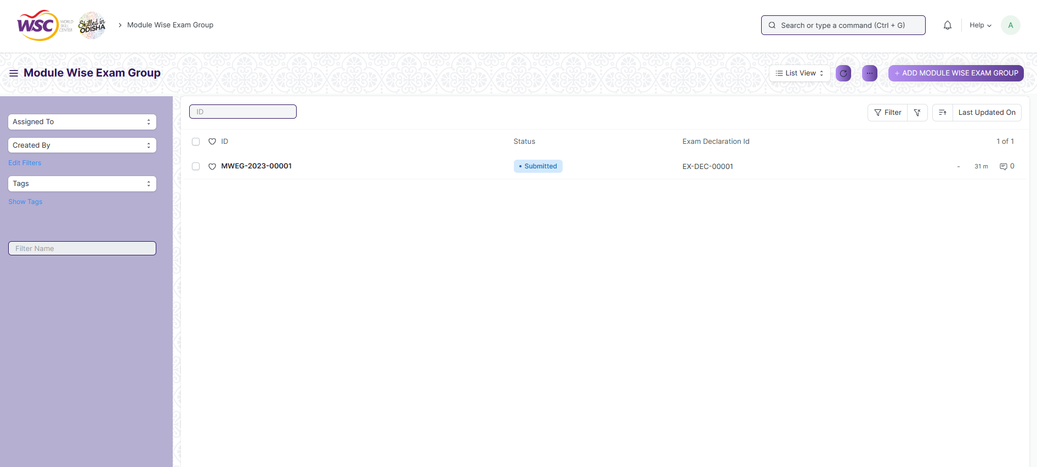

(List view of Module Wise Exam Group)

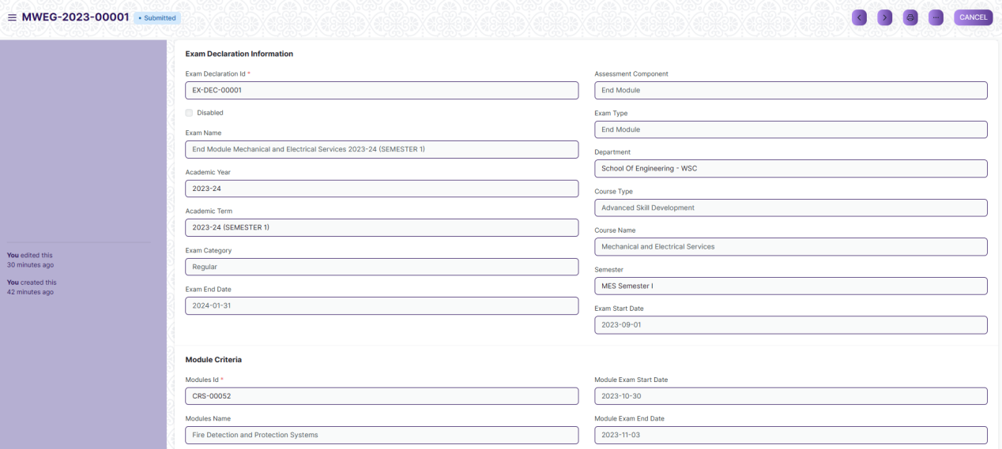

(View a saved record)

**Screen Type**

* Submittable

**Prerequisites**

* Exam Declaration

**Adding a new record**

As it is a submittable screen, follow the general procedure to create a submittable document as mentioned above .

After creating a Module Wise Exam Group, the record will be visible in the List view of the screen.

**Deleting a record**

As it a submittable screen , follow the general procedure to delete a submittable document .

**Edit Record**

Follow the steps to view a saved Module Wise Exam Group.

Edit the field that you want to change.

If submitted, follow the general procedure to cancel and amend the document.

Click on Save.

**Print Record**

As it is a submittable screen , follow the general procedure to print a submittable document.

**View Record in different format**

As it is a submittable screen, follow the general procedure to view a submittable document in different format.

## Exam Evaluation Plan

**Description**

An Exam Evaluation Plan is a schedule to conduct the examination/assessment of a particular course for a group of students studying that course in an on-going academic term.

To access the Exam Evaluation Plan screen ,go to :

***Home>Examination>Examination>Exam Evaluation Plan***

**Screen**

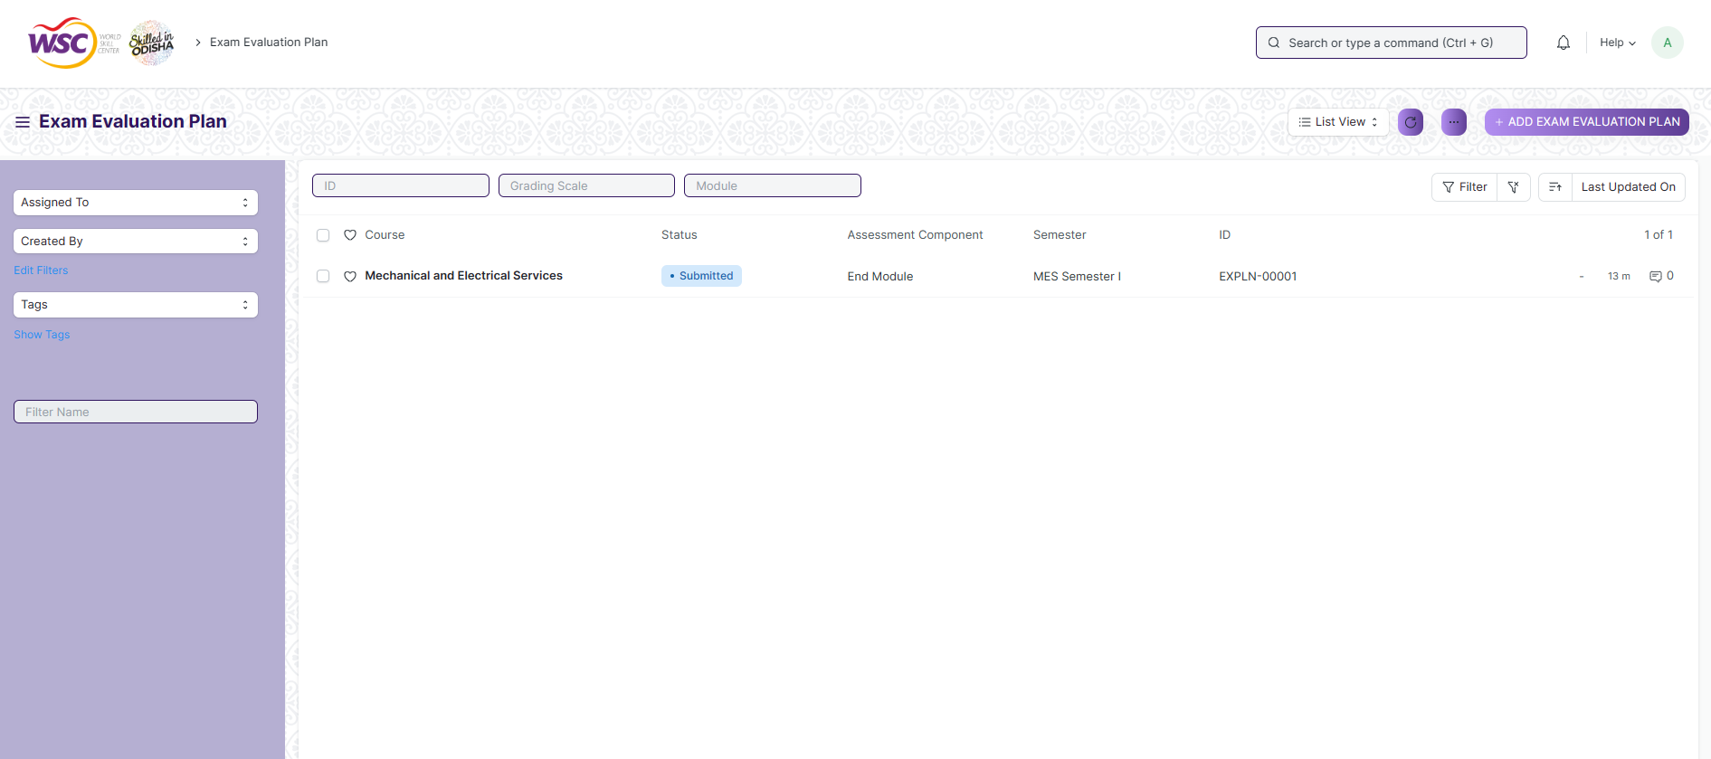

(List view of Exam Evaluation Plan)

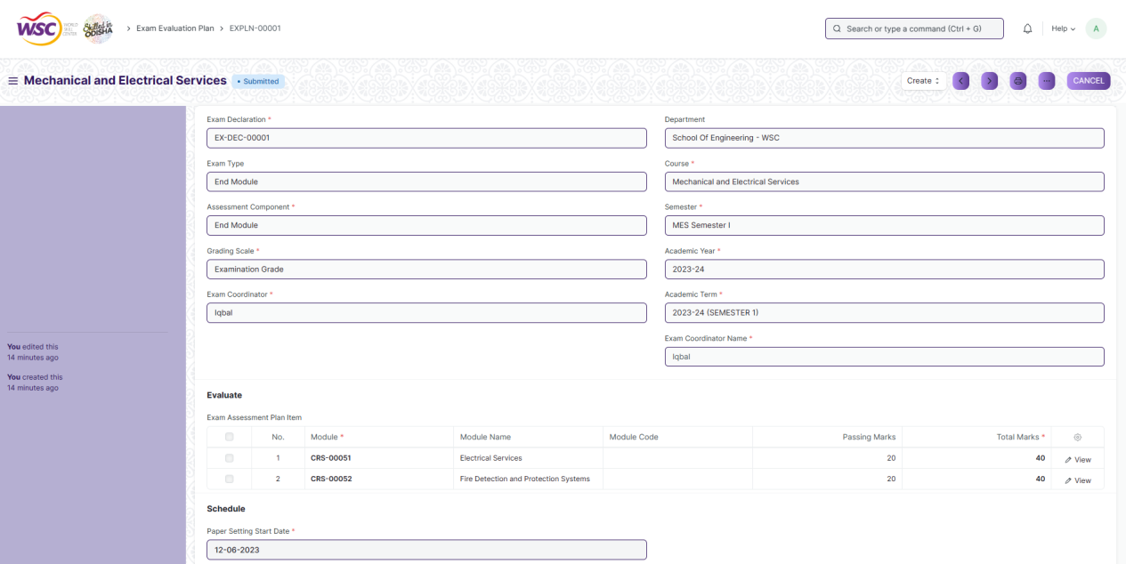

(View a saved record)

**Screen Type**

* Submittable

**Prerequisites**

* Exam Declaration

**Adding a new record**

As it is a submittable screen, follow the general procedure to create a submittable document as mentioned above .

After creating a Exam Evaluation Plan, the record will be visible in the List view of the screen.

**Deleting a record**

As it a submittable screen , follow the general procedure to delete a submittable document .

**Edit Record**

Follow the steps to view a saved Exam Evaluation Plan.

Edit the field that you want to change.

If submitted, follow the general procedure to cancel and amend the document.

Click on Save.

**Print Record**

As it is a submittable screen , follow the general procedure to print a submittable document.

**View Record in different format**

As it is a submittable screen, follow the general procedure to view a submittable document in different format.

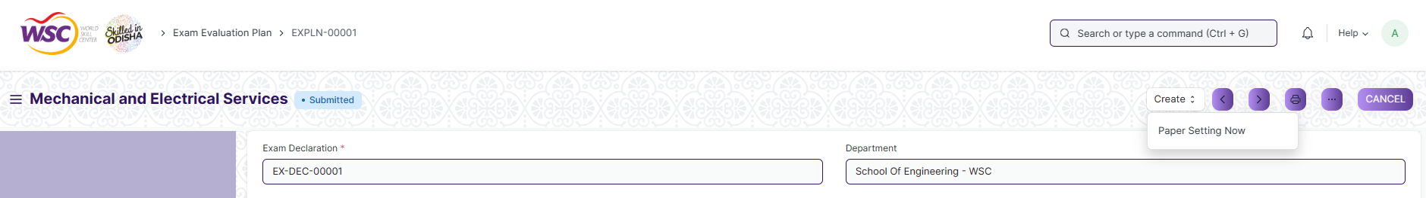

(Buttons)

**Buttons**

The buttons appear after the form is submitted. Under the ‘Create’ button, there is one button which is as follows:

1. Paper Setting Now : This button will create records in the Exam Paper Setting Screen based on form input.

## Exam Paper Setting

**Description**

The Exam Paper Setting is used to prepare paper setting schedules and plan for paper setters and moderators for a particular exam declaration.

To access the Exam Paper Setting screen ,go to :

***Home>Examination>Examination>Exam Paper Setting***

**Screen**

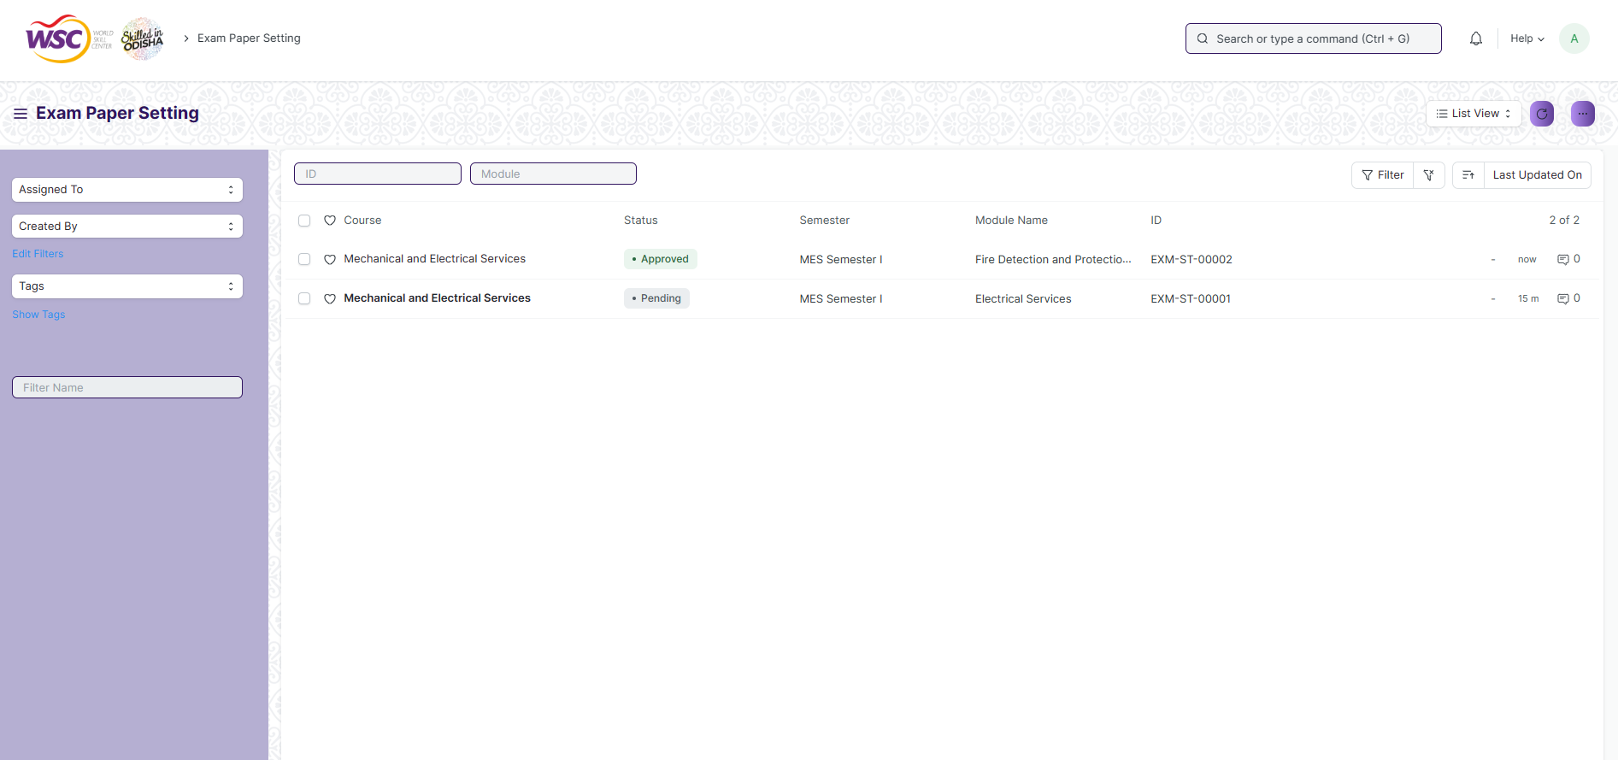

(List view of Exam Paper Setting)

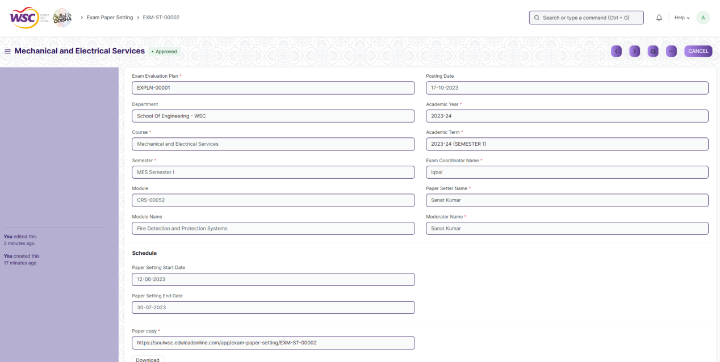

(View a saved record)

**Screen Type**

* Submittable

**Prerequisites**

* Exam Evaluation Plan

**Adding a new record**

As it is a submittable screen, follow the general procedure to create a submittable document as mentioned above .

After creating a Exam Paper Setting, the record will be visible in the List view of the screen.

**Deleting a record**

As it a submittable screen , follow the general procedure to delete a submittable document .

**Edit Record**

Follow the steps to view a saved Exam Paper Setting.

Edit the field that you want to change.

If submitted, follow the general procedure to cancel and amend the document.

Click on Save.

**Print Record**

As it is a submittable screen , follow the general procedure to print a submittable document.

**View Record in different format**

As it is a submittable screen, follow the general procedure to view a submittable document in different format.

## Student Backpaper Tracking

**Description**

Back Paper Tracking is used to actively track and maintain the history of the whole Examination process of a student who has failed in one or more modules.

To access the Back Paper Tracking screen ,go to :

***Home>Examination>Examination>Student Backpaper Tracking***

**Screen**

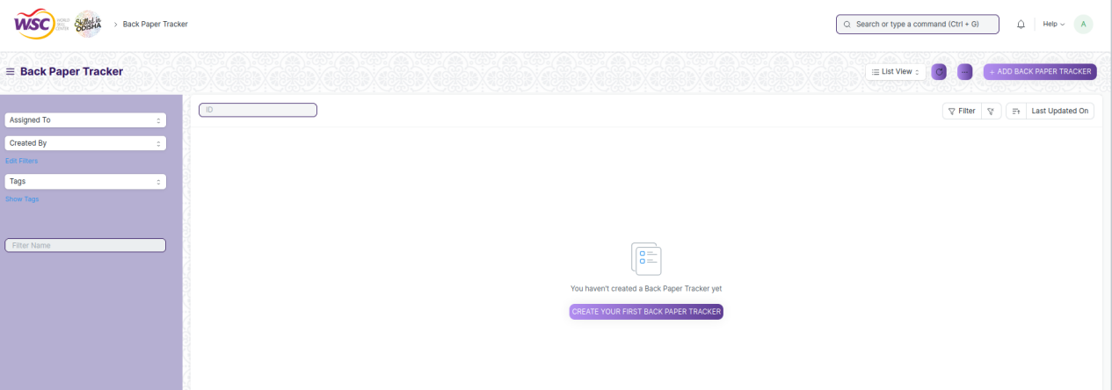

(List view of Back Paper Tracking)

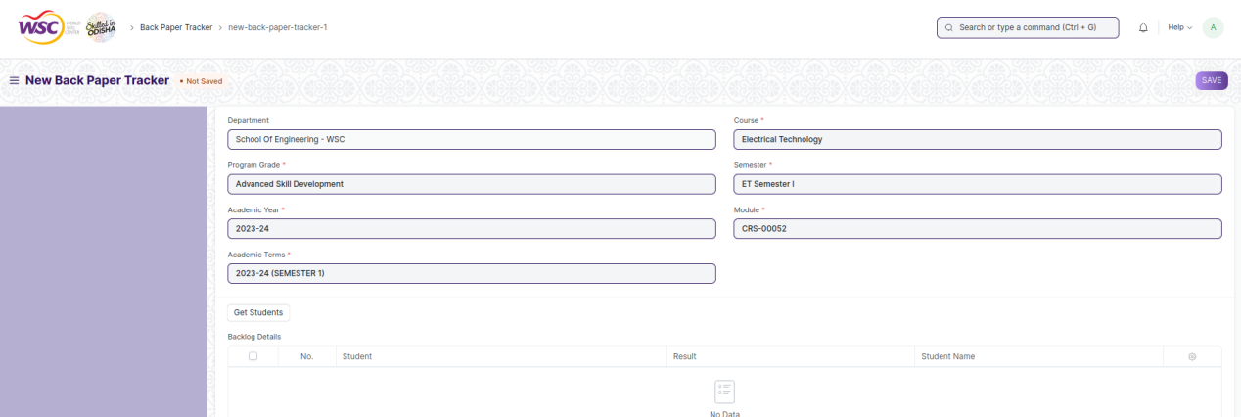

(View a saved record)

**Screen Type**

* Submittable

**Prerequisites**

* Final Exam Result

**Adding a new record**

As it is a submittable screen, follow the general procedure to create a submittable document as mentioned above .

After creating a Back Paper Tracking, the record will be visible in the List view of the screen.

**Deleting a record**

As it a submittable screen , follow the general procedure to delete a submittable document .

**Edit Record**

Follow the steps to view a saved Back Paper Tracking.

Edit the field that you want to change.

If submitted, follow the general procedure to cancel and amend the document.

Click on Save.

**Print Record**

As it is a submittable screen , follow the general procedure to print a submittable document.

**View Record in different format**

As it is a submittable screen, follow the general procedure to view a submittable document in different format.

# Tools

## Component Wise Evaluation Tool

**Description**

Component Wise Evaluation Tool helps in entering marks earned by the students in a semester for a particular course and particular assessment component.

To access the Component Wise Evaluation Tool screen ,go to :

***Home>Examination>Tools>Component Wise Evaluation Tool***

**Screen**

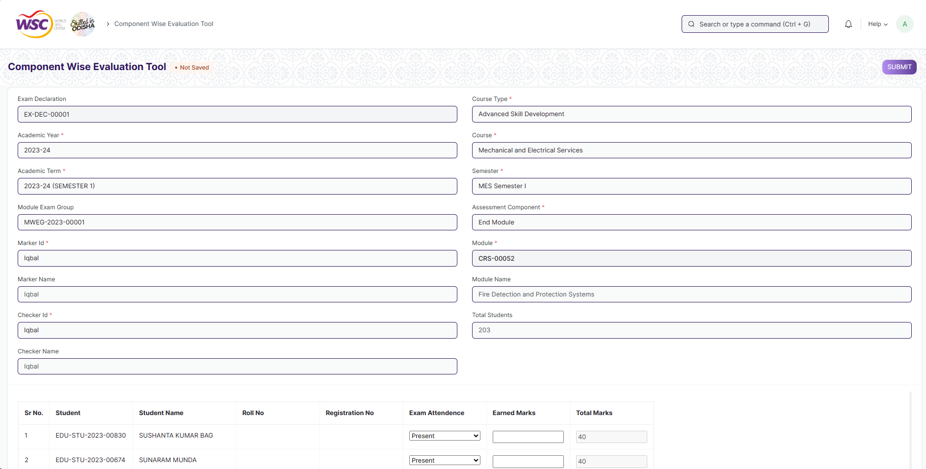

( view of Component Wise Evaluation Tool)

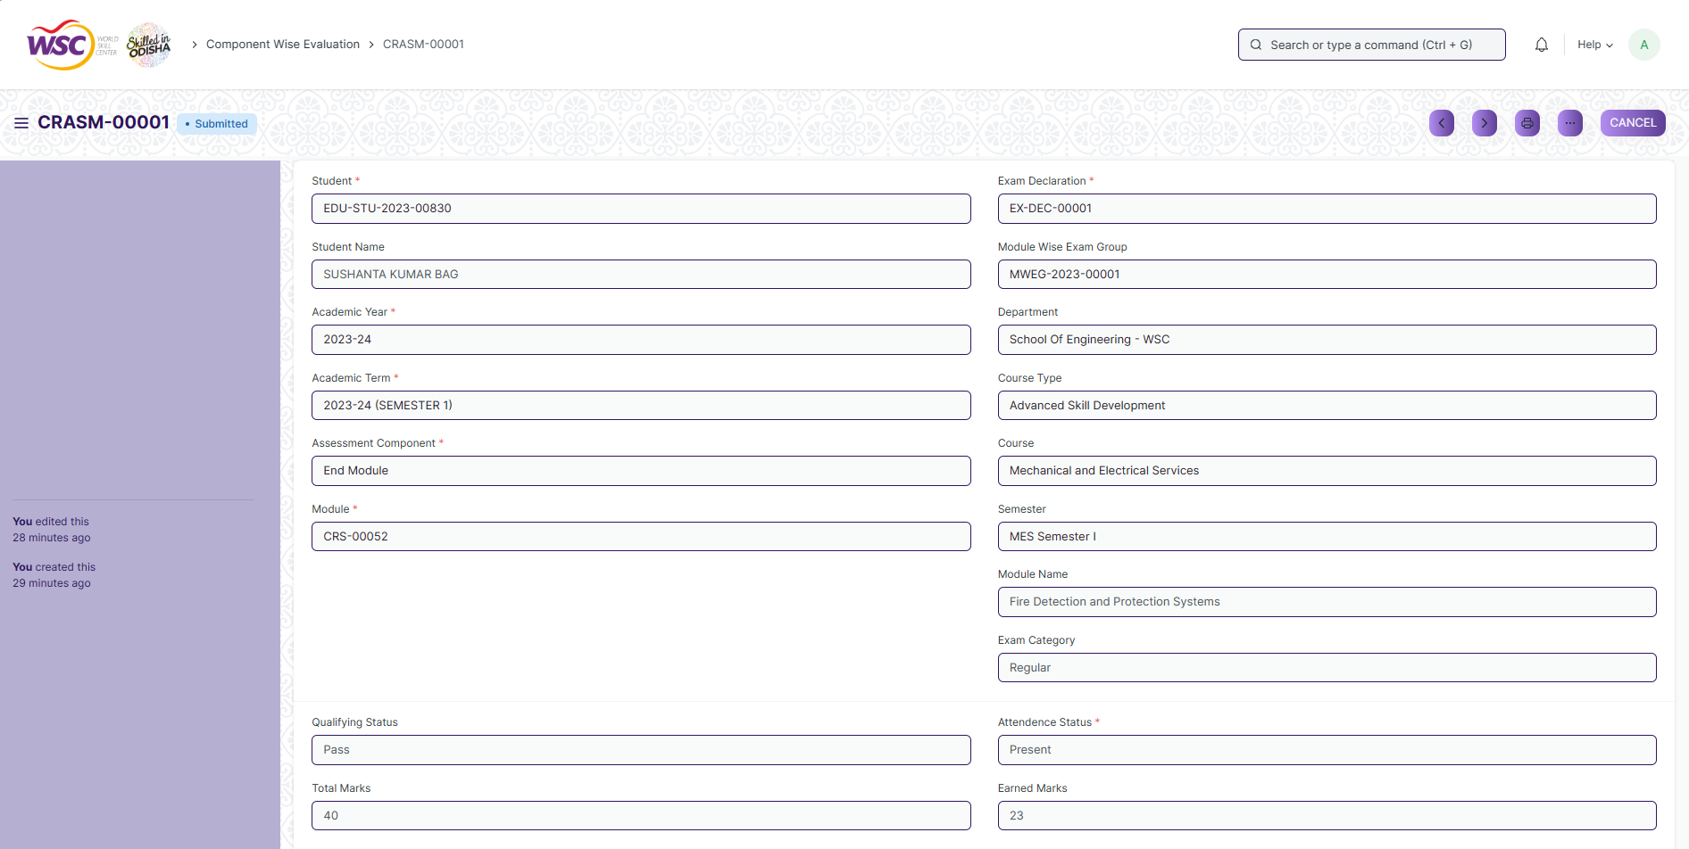

(View a saved record which gets created from the tool)

**Screen Type**

* Tool

**Prerequisites**

* Exam Declaration, Module Wise Exam Group

**Adding a new record**

As it is a tool screen, records are created on another screen which is component wise evaluation.

After submitting a component wise evaluation tool, the record will be visible in the List view of the component wise evaluation screen.

**Deleting a record**

As it a submittable(component wise evaluation) screen , follow the general procedure to delete a submittable document .

**Edit Record**

Follow the steps to view a saved component wise evaluation.

Edit the field that you want to change.

If submitted, follow the general procedure to cancel and amend the document.

Click on Save.

**Print Record**

As it is a submittable(component wise evaluation) screen , follow the general procedure to print a submittable document.

**View Record in different format**

As it is a submittable(component wise evaluation) screen, follow the general procedure to view a submittable document in different format.

## Component Wise Reevaluation Tool

**Description**

Component Wise Reevaluation Tool helps in entering marks earned by the students in a semester for a particular course and particular assessment component.

To access the Component Wise Evaluation Tool screen ,go to :

***Home>Examination>Tools>Component Wise Re Evaluation Tool***

**Screen**

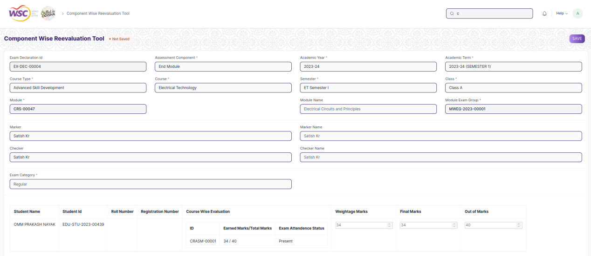

( view of Component Wise Re-Evaluation Tool)

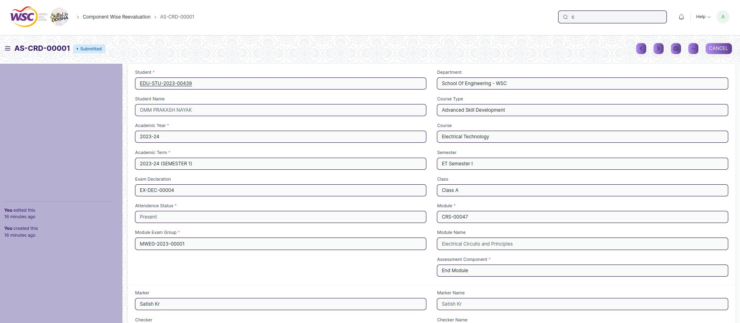

(View a saved record which gets created from the tool)

**Screen Type**

* Tool

**Prerequisites**

* Exam Declaration, Module Wise Exam Group

**Adding a new record**

As it is a tool screen, records are created on another screen which is component wise reevaluation.

After submitting a component wise reevaluation tool, the record will be visible in the List view of the component wise evaluation screen.

**Deleting a record**

As it a submittable(component wise reevaluation) screen , follow the general procedure to delete a submittable document .

**Edit Record**

Follow the steps to view a saved component wise evaluation.

Edit the field that you want to change.

If submitted, follow the general procedure to cancel and amend the document.

Click on Save.

**Print Record**

As it is a submittable(component wise reevaluation) screen , follow the general procedure to print a submittable document.

**View Record in different format**

As it is a submittable(component wise reevaluation) screen, follow the general procedure to view a submittable document in different format.

## Cumulative Marksheet Tool

**Description**

Cumulative Marksheet Tool is a compilation of all the semesters with their grades in a single certificate. The Cumulative marksheet will have a list of subjects, grades obtained and CGPA (Cumulative Grade Point Average). And also details of students, such as roll number, name, age and date of birth, program enrollment.

To access the Cumulative Marksheet Tool screen ,go to :

***Home>Examination>Tools>Cumulative Marksheet Tool***

**Screen**

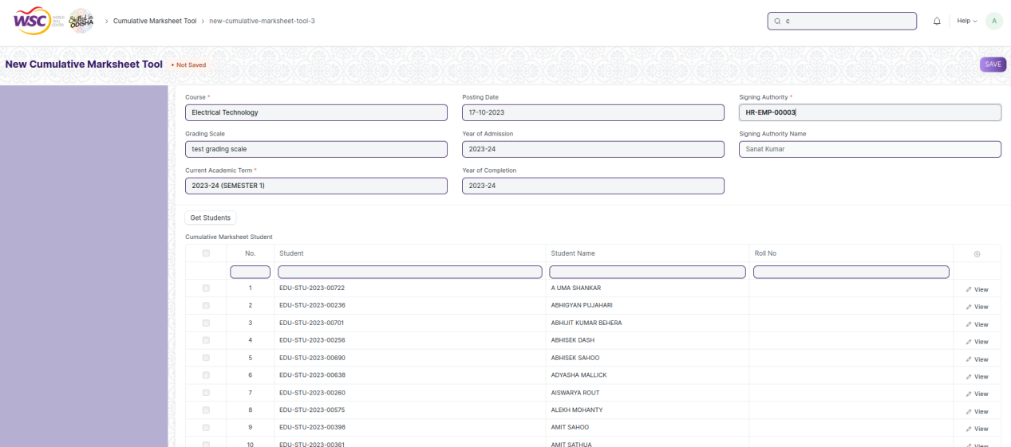

( view of Cumulative Marksheet Tool)

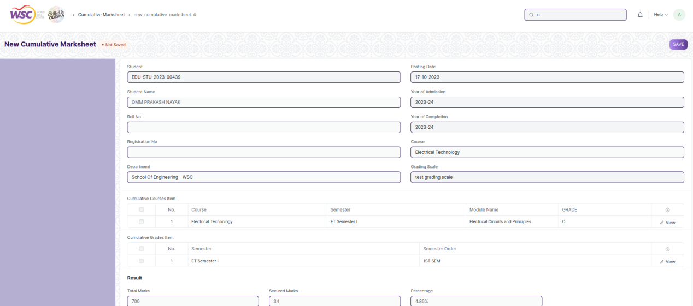

(View a saved record which gets created from the tool)

**Screen Type**

* Tool

**Prerequisites**

* Exam Declaration, Module Wise Exam Group

**Adding a new record**

As it is a tool screen, records are created on another screen which is Cumulative Marksheet.

After submitting a Cumulative Marksheet tool, the record will be visible in the List view of the component wise evaluation screen.

**Deleting a record**

As it a submittable(Cumulative Marksheet) screen , follow the general procedure to delete a submittable document .

**Edit Record**

Follow the steps to view a saved Cumulative Marksheet.

Edit the field that you want to change.

If submitted, follow the general procedure to cancel and amend the document.

Click on Save.

**Print Record**

As it is a submittable(Cumulative Marksheet) screen , follow the general procedure to print a submittable document.

**View Record in different format**

As it is a submittable(Cumulative Marksheet) screen, follow the general procedure to view a submittable document in different format.

## Final Semester Result Tool

**Description**

Final Semester Result Tool is used to declare the final exam results for a particular group/batch of students in a semester.

To access the Final Semester Result Tool screen ,go to :

***Home>Examination>Tools>Final Semester Result Tool***

**Screen**

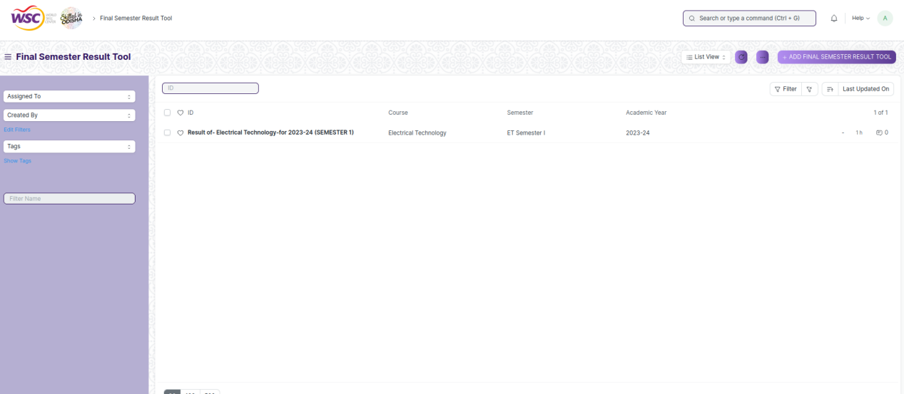

(list view of Final Semester Result Tool)

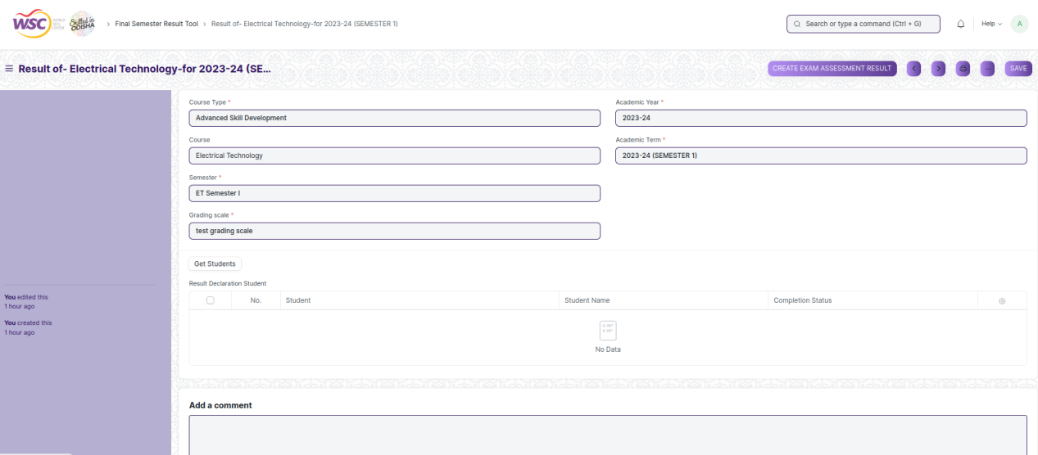

(View a saved record)

**Screen Type**

* Tool

**Prerequisites**

* Exam Declaration, Module Wise Exam Group

**Adding a new record**

As it is a tool screen, records are created on another screen which is Final Semester Result.

After submitting a Final Semester Result Tool, the record will be visible in the List view of the component wise evaluation screen.

**Deleting a record**

As it a submittable( Final Semester Result) screen , follow the general procedure to delete a submittable document .

**Edit Record**

Follow the steps to view a saved Final Semester Result.

Edit the field that you want to change.

If submitted, follow the general procedure to cancel and amend the document.

Click on Save.

**Print Record**

As it is a submittable(Final Semester Result) screen , follow the general procedure to print a submittable document.

**View Record in different format**

As it is a submittable(Final Semester Result) screen, follow the general procedure to view a submittable document in different format.

# Evaluation

## Component Wise Evaluation

**Description**

Component Wise Evaluation allows us to create an evaluation for a particular assessment criterion in a course for a student enrolled in that course.

To access the Component Wise Evaluation screen ,go to :

***Home>Examination>Evaluation>Component Wise Evaluation***

**Screen**

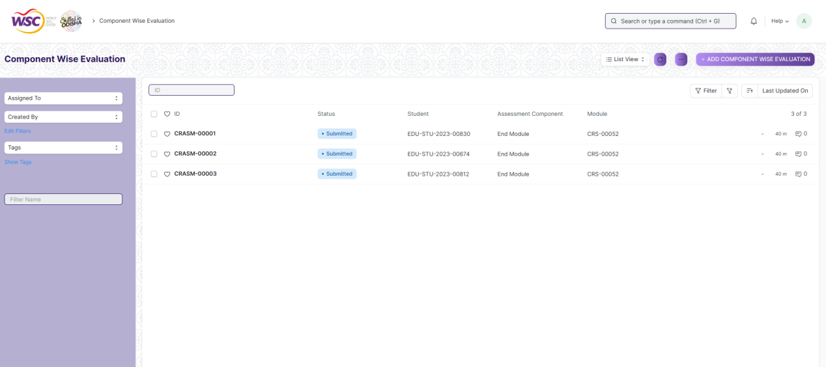

( list view of Component Wise Evaluation)



(View a saved record which gets created)

**Screen Type**

* Submittable

**Prerequisites**

* Exam Declaration, Module Wise Exam Group

**Adding a new record**

As it is a submittable screen, follow the general procedure to create a submittable document as mentioned above .

After creating a Component Wise Evaluation, the record will be visible in the List view of the screen.

**Deleting a record**

As it a submittable screen , follow the general procedure to delete a submittable document .

**Edit Record**

Follow the steps to view a saved component wise evaluation.

Edit the field that you want to change.

If submitted, follow the general procedure to cancel and amend the document.

Click on Save.

**Print Record**

As it is a submittable screen , follow the general procedure to print a submittable document.

**View Record in different format**

As it is a submittable screen, follow the general procedure to view a submittable document in different format.

## Component Wise Reevaluation

**Description**

Component Wise Reevaluation allows us to create an evaluation for a particular assessment criterion in a course for a student enrolled in that course.

To access the Component Wise Reevaluation screen ,go to :

***Home>Examination>Evaluation>Component Wise Reevaluation***

**Screen**

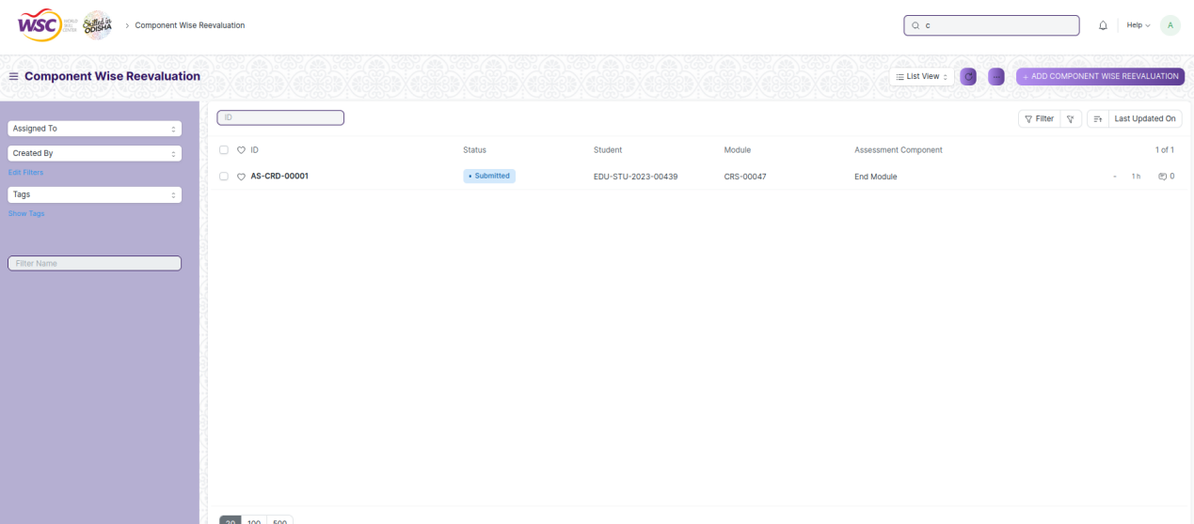

( list view of Component Wise Reevaluation)



(View a saved record which gets created)

**Screen Type**

* Submittable

**Prerequisites**

* Exam Declaration, Module Wise Exam Group

**Adding a new record**

As it is a submittable screen, follow the general procedure to create a submittable document as mentioned above .

After creating a Component Wise Reevaluation, the record will be visible in the List view of the screen.

**Deleting a record**

As it a submittable screen , follow the general procedure to delete a submittable document .

**Edit Record**

Follow the steps to view a saved Component Wise Reevaluation.

Edit the field that you want to change.

If submitted, follow the general procedure to cancel and amend the document.

Click on Save.

**Print Record**

As it is a submittable screen , follow the general procedure to print a submittable document.

**View Record in different format**

As it is a submittable screen, follow the general procedure to view a submittable document in different format.

## Final Semester Result

**Description**

Final Exam Result is used to evaluate the final assessment of a student for a particular semester.

To access the Final Exam Result screen ,go to :

***Home>Examination>Evaluation>Final Exam Result***

**Screen**

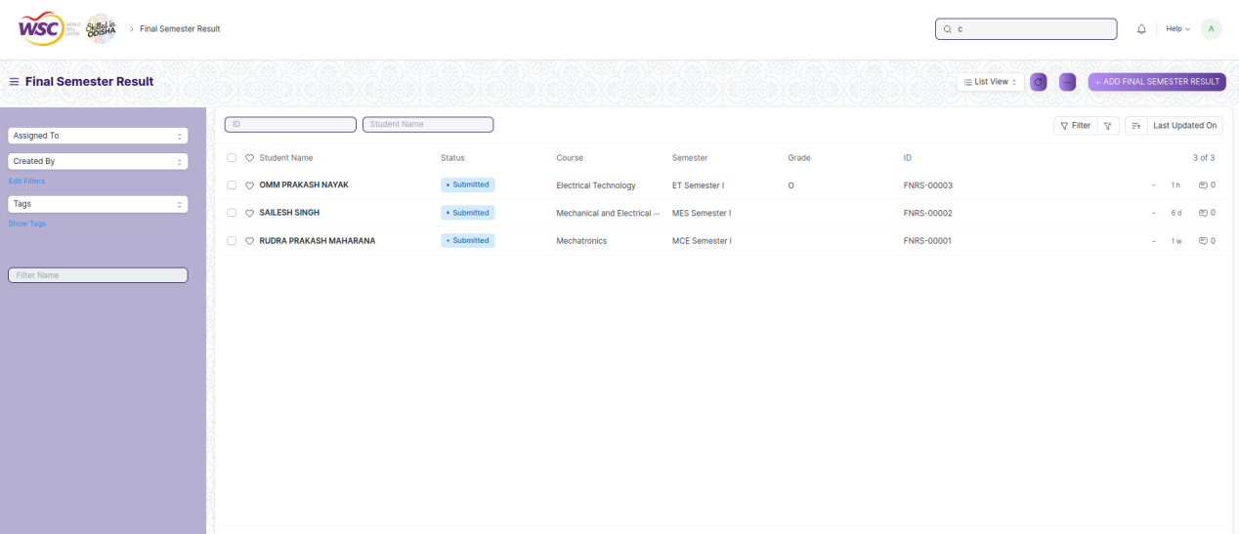

( list view of Final Exam Result)

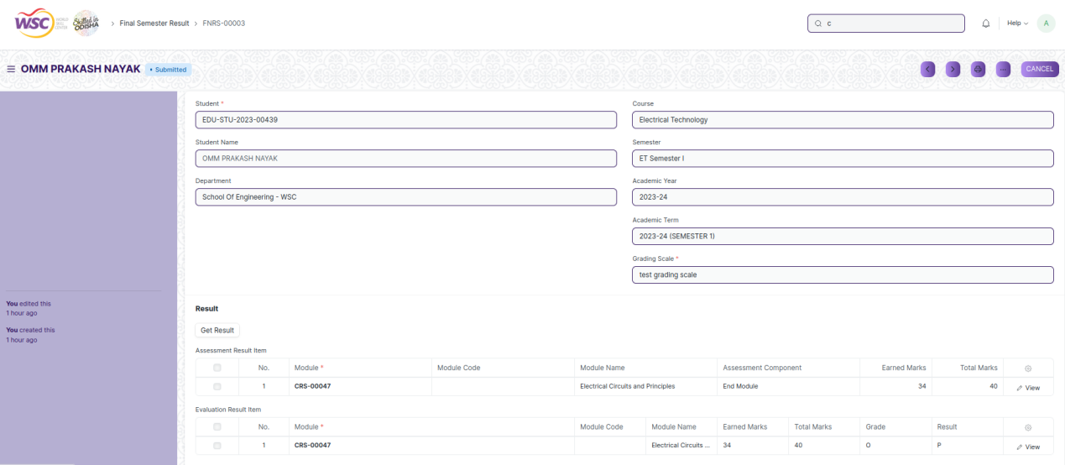

(View a saved record which gets created)

**Screen Type**

* Submittable

**Prerequisites**

* Exam Declaration, Module Wise Exam Group

**Adding a new record**

As it is a submittable screen, follow the general procedure to create a submittable document as mentioned above .

After creating a Final Exam Result, the record will be visible in the List view of the screen.

**Deleting a record**

As it a submittable screen , follow the general procedure to delete a submittable document .

**Edit Record**

Follow the steps to view a saved Final Exam Result.

Edit the field that you want to change.

If submitted, follow the general procedure to cancel and amend the document.

Click on Save.

**Print Record**

As it is a submittable screen , follow the general procedure to print a submittable document.

**View Record in different format**

As it is a submittable screen, follow the general procedure to view a submittable document in different format.

# Reports

## Final Semester Result Report

**Description**

This report is used to generate final semester result of the students of a semester in a single screen.

To access the Final Semester Result Report screen ,go to :

***Home>Examination>Reports>Final Semester Result Report***

**Screen**

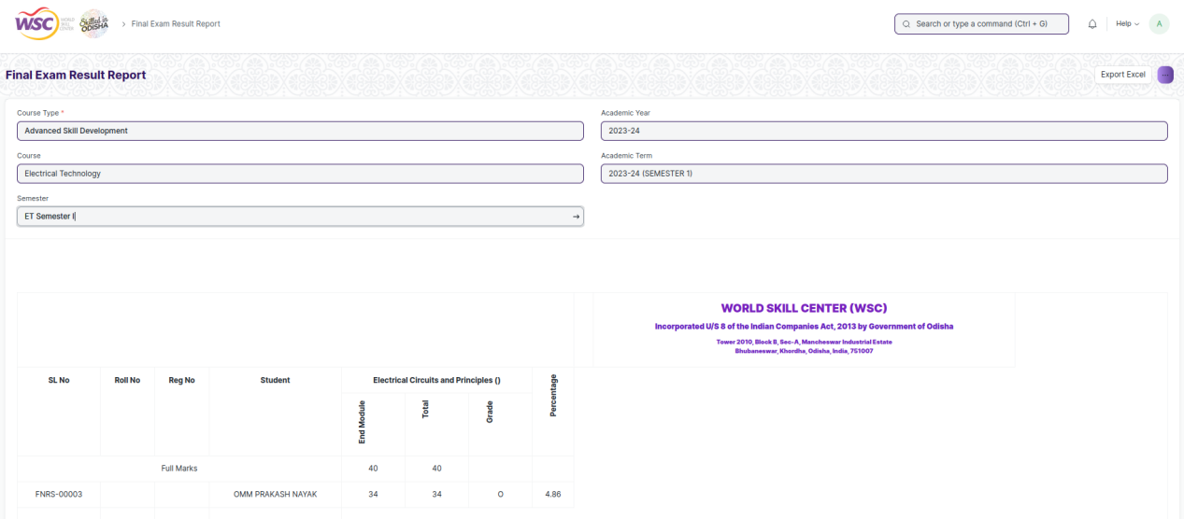

(View a saved record which gets created)

**Screen Type**

* Submittable

**Prerequisites**

* Exam Declaration, Module Wise Exam Group

**Adding a new record**

As it is a submittable screen, follow the general procedure to create a submittable document as mentioned above .

After creating a Final Semester Result Report, the record will be visible in the List view of the screen.

**Deleting a record**

As it a submittable screen , follow the general procedure to delete a submittable document .

**Edit Record**

Follow the steps to view a saved Final Semester Result.

Edit the field that you want to change.

If submitted, follow the general procedure to cancel and amend the document.

Click on Save.

**Print Record**

As it is a submittable screen , follow the general procedure to print a submittable document.

**View Record in different format**

As it is a submittable screen, follow the general procedure to view a submittable document in different format.

**Buttons**

Click on the ‘Export Excel’ button to export and download the report in excel format.

## Course Wise Performance

**Description**

This report is used to access the course wise performance.

To access the Course Wise Performance screen ,go to :

***Home>Examination>Reports>Course Wise Performance***

**Screen**

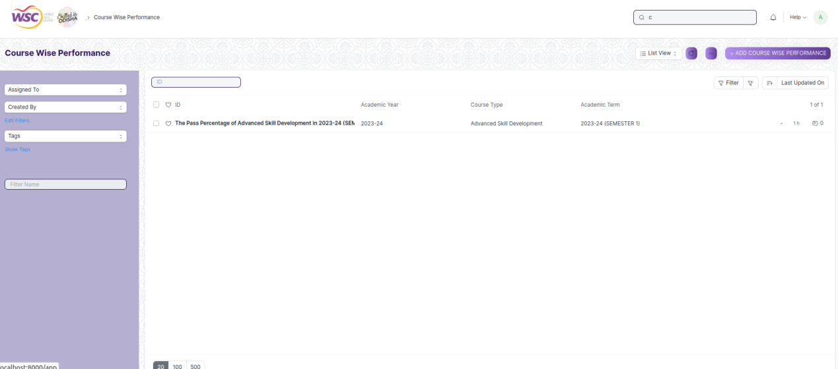

(list view of Course Wise Performance)

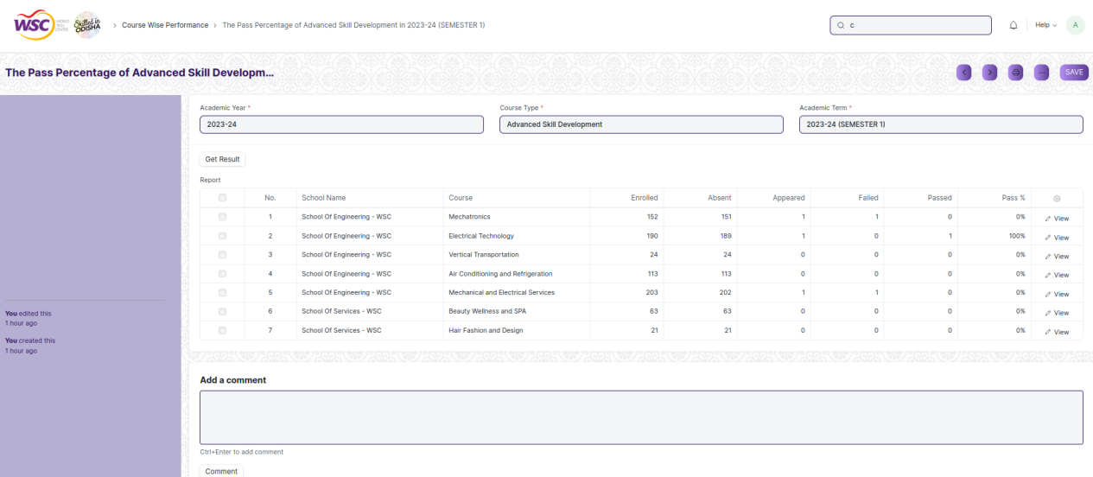

(View a saved record which gets created)

**Screen Type**

* Save

**Prerequisites**

* Exam Declaration, Module Wise Exam Group

**Adding a new record**

As it is a save screen, follow the general procedure to create a save document as mentioned above .

After creating a Course Wise Performance, the record will be visible in the List view of the screen.

**Deleting a record**

As it a Save screen , follow the general procedure to delete a save document .

**Edit Record**

Follow the steps to view a saved Course Wise Performance.

Edit the field that you want to change.

Click on Save.

**Print Record**

As it is a Save screen , follow the general procedure to print a saved document.

**View Record in different format**

As it is a Save screen , follow the general procedure to view a saved document in different format.

## Module Wise Performance

**Description**

This report is used to access the module wise performance.

To access the Module Wise Performance screen ,go to :

***Home>Examination>Reports>Module Wise Performance***

**Screen**

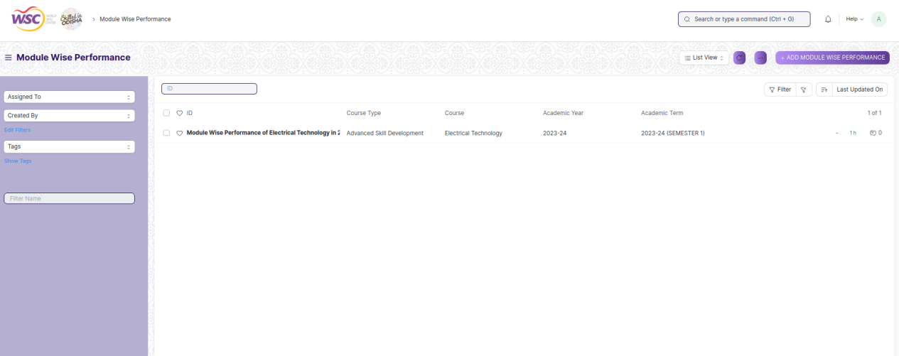

(list view of Module Wise Performance)

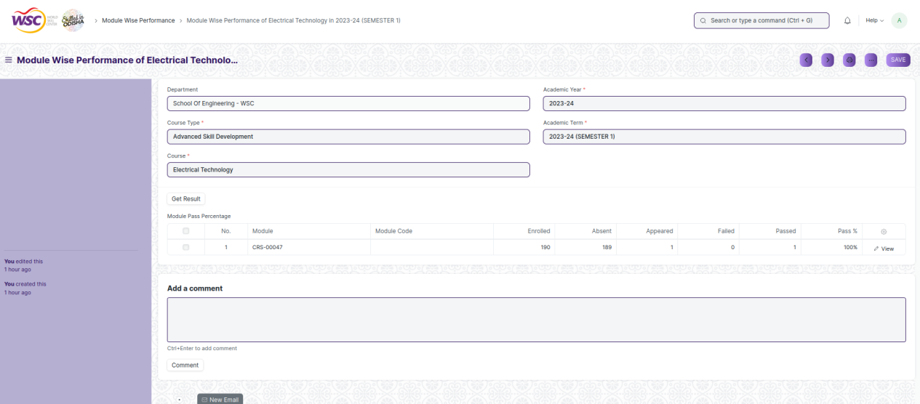

(View a saved record which gets created)

**Screen Type**

* Save

**Prerequisites**

* Final Exam Result

**Adding a new record**

As it is a save screen, follow the general procedure to create a save document as mentioned above .

After creating a Module Wise Performance, the record will be visible in the List view of the screen.

**Deleting a record**

As it a Save screen , follow the general procedure to delete a save document .

**Edit Record**

Follow the steps to view a saved Module Wise Performance.

Edit the field that you want to change.

Click on Save.

**Print Record**

As it is a Save screen , follow the general procedure to print a saved document.

**View Record in different format**

As it is a Save screen , follow the general procedure to view a saved document in different format.

# Transcripts

## Cumulative Marksheet

**Description**

Cumulative Marksheet is a compilation of all the semesters with their grades in a single certificate. The Cumulative marksheet will have a list of subjects, grades obtained and CGPA (Cumulative Grade Point Average). And also details of students, such as roll number, name, age and date of birth, program enrollment.

To access the Cumulative Marksheet screen ,go to :

***Home>Examination>Transcripts>Cumulative Marksheet***

**Screen**

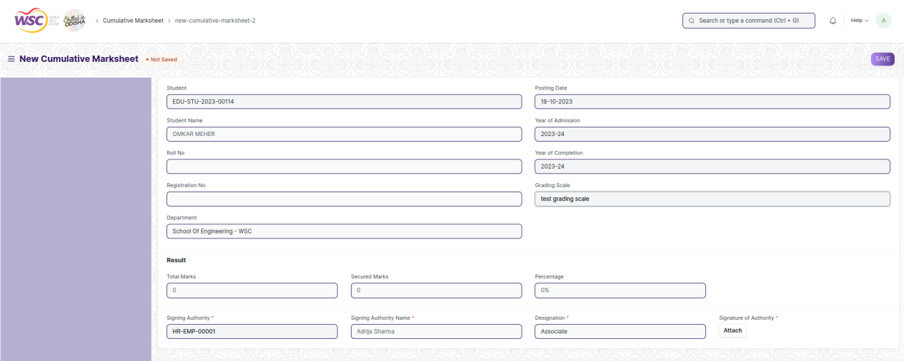

(View a record which gets created)

**Screen Type**

* Submittable

**Prerequisites**

* Final Exam Result

**Adding a new record**

As it is a submittable screen, follow the general procedure to create a submittable document as mentioned above .

After creating a Cumulative Marksheet, the record will be visible in the List view of the screen.

**Deleting a record**

As it a submittable screen , follow the general procedure to delete a submittable document .

**Edit Record**

Follow the steps to view a saved Cumulative Marksheet.

Edit the field that you want to change.

If submitted, follow the general procedure to cancel and amend the document.

Click on Save.

**Print Record**

As it is a submittable screen , follow the general procedure to print a submittable document.

**View Record in different format**

As it is a submittable screen, follow the general procedure to view a submittable document in different format.

# Security: User access and authorization

The screens and the data in them is made secure by creating roles with different permissions and then assigning those roles the appropriate users. For this screen, following are the roles and their corresponding permissions:

**Exam Type**

|  |  |  |  |  |  |  |  |  |
| --- | --- | --- | --- | --- | --- | --- | --- | --- |
| **ID** | **Role** | **Read** | **Write** | **Create** | **Delete** | **Submit** | **Cancel** | **Amend** |
| 1 | SLCM Admin | Yes | Yes | Yes | Yes | Yes | Yes | Yes |
| 2 | Trainer | Yes | No | No | No | NA | NA | NA |
| 3 | Exam Coordinator | Yes | Yes | Yes | Yes | Yes | Yes | Yes |

**Assessment Component**

|  |  |  |  |  |  |  |  |  |
| --- | --- | --- | --- | --- | --- | --- | --- | --- |
| **ID** | **Role** | **Read** | **Write** | **Create** | **Delete** | **Submit** | **Cancel** | **Amend** |
| 1 | SLCM Admin | Yes | Yes | Yes | Yes | Yes | Yes | Yes |
| 2 | Trainer | Yes | No | No | No | NA | NA | NA |
| 3 | Exam Coordinator | Yes | Yes | Yes | Yes | Yes | Yes | Yes |

**Grading Scale**

|  |  |  |  |  |  |  |  |  |
| --- | --- | --- | --- | --- | --- | --- | --- | --- |
| **ID** | **Role** | **Read** | **Write** | **Create** | **Delete** | **Submit** | **Cancel** | **Amend** |
| 1 | SLCM Admin | Yes | Yes | Yes | Yes | Yes | Yes | Yes |
| 2 | Trainer | Yes | No | No | No | NA | NA | NA |
| 3 | Exam Coordinator | Yes | Yes | Yes | Yes | Yes | Yes | Yes |

**Exam Declaration**

|  |  |  |  |  |  |  |  |  |
| --- | --- | --- | --- | --- | --- | --- | --- | --- |
| **ID** | **Role** | **Read** | **Write** | **Create** | **Delete** | **Submit** | **Cancel** | **Amend** |
| 1 | SLCM Admin | Yes | Yes | Yes | Yes | Yes | Yes | Yes |
| 2 | Trainer | Yes | No | No | No | NA | NA | NA |
| 3 | Exam Coordinator | Yes | Yes | Yes | Yes | Yes | Yes | Yes |

**Module Wise Exam Group**

|  |  |  |  |  |  |  |  |  |
| --- | --- | --- | --- | --- | --- | --- | --- | --- |
| **ID** | **Role** | **Read** | **Write** | **Create** | **Delete** | **Submit** | **Cancel** | **Amend** |
| 1 | SLCM Admin | Yes | Yes | Yes | Yes | Yes | Yes | Yes |
| 2 | Trainer | Yes | No | No | No | NA | NA | NA |
| 3 | Exam Coordinator | Yes | Yes | Yes | Yes | Yes | Yes | Yes |

**Exam Evaluation Plan**

|  |  |  |  |  |  |  |  |  |
| --- | --- | --- | --- | --- | --- | --- | --- | --- |
| **ID** | **Role** | **Read** | **Write** | **Create** | **Delete** | **Submit** | **Cancel** | **Amend** |
| 1 | SLCM Admin | Yes | Yes | Yes | Yes | Yes | Yes | Yes |
| 2 | Trainer | Yes | No | No | No | NA | NA | NA |
| 3 | Exam Coordinator | Yes | Yes | Yes | Yes | Yes | Yes | Yes |

**Exam Paper Setting**

|  |  |  |  |  |  |  |  |  |
| --- | --- | --- | --- | --- | --- | --- | --- | --- |
| **ID** | **Role** | **Read** | **Write** | **Create** | **Delete** | **Submit** | **Cancel** | **Amend** |
| 1 | SLCM Admin | Yes | Yes | Yes | Yes | Yes | Yes | Yes |
| 2 | Trainer | Yes | No | No | No | NA | NA | NA |
| 3 | Exam Coordinator | Yes | Yes | Yes | Yes | Yes | Yes | Yes |

**Component Wise Evaluation**

|  |  |  |  |  |  |  |  |  |
| --- | --- | --- | --- | --- | --- | --- | --- | --- |
| **ID** | **Role** | **Read** | **Write** | **Create** | **Delete** | **Submit** | **Cancel** | **Amend** |
| 1 | SLCM Admin | Yes | Yes | Yes | Yes | Yes | Yes | Yes |
| 2 | Trainer | Yes | Yes | Yes | Yes | Yes | Yes | Yes |
| 3 | Exam Coordinator | Yes | Yes | Yes | Yes | Yes | Yes | Yes |

**Component Wise Evaluation Tool**

|  |  |  |  |  |  |  |  |  |
| --- | --- | --- | --- | --- | --- | --- | --- | --- |
| **ID** | **Role** | **Read** | **Write** | **Create** | **Delete** | **Submit** | **Cancel** | **Amend** |
| 1 | SLCM Admin | Yes | Yes | Yes | Yes | Yes | Yes | Yes |
| 2 | Trainer | Yes | Yes | Yes | Yes | Yes | Yes | Yes |
| 3 | Exam Coordinator | Yes | Yes | Yes | Yes | Yes | Yes | Yes |

**Component Wise Reevaluation**

|  |  |  |  |  |  |  |  |  |
| --- | --- | --- | --- | --- | --- | --- | --- | --- |
| **ID** | **Role** | **Read** | **Write** | **Create** | **Delete** | **Submit** | **Cancel** | **Amend** |
| 1 | SLCM Admin | Yes | Yes | Yes | Yes | Yes | Yes | Yes |
| 2 | Trainer | Yes | Yes | Yes | Yes | Yes | Yes | Yes |
| 3 | Exam Coordinator | Yes | Yes | Yes | Yes | Yes | Yes | Yes |

**Component Wise Reevaluation Tool**

|  |  |  |  |  |  |  |  |  |
| --- | --- | --- | --- | --- | --- | --- | --- | --- |
| **ID** | **Role** | **Read** | **Write** | **Create** | **Delete** | **Submit** | **Cancel** | **Amend** |
| 1 | SLCM Admin | Yes | Yes | Yes | Yes | Yes | Yes | Yes |
| 2 | Trainer | Yes | Yes | Yes | Yes | Yes | Yes | Yes |
| 3 | Exam Coordinator | Yes | Yes | Yes | Yes | Yes | Yes | Yes |

**Final Semester Result**

|  |  |  |  |  |  |  |  |  |
| --- | --- | --- | --- | --- | --- | --- | --- | --- |
| **ID** | **Role** | **Read** | **Write** | **Create** | **Delete** | **Submit** | **Cancel** | **Amend** |
| 1 | SLCM Admin | Yes | Yes | Yes | Yes | Yes | Yes | Yes |
| 2 | Trainer | Yes | No | No | No | NA | NA | NA |
| 3 | Exam Coordinator | Yes | Yes | Yes | Yes | Yes | Yes | Yes |

**Final Semester Result Tool**

|  |  |  |  |  |  |  |  |  |
| --- | --- | --- | --- | --- | --- | --- | --- | --- |
| **ID** | **Role** | **Read** | **Write** | **Create** | **Delete** | **Submit** | **Cancel** | **Amend** |
| 1 | SLCM Admin | Yes | Yes | Yes | Yes | Yes | Yes | Yes |
| 2 | Trainer | Yes | No | No | No | NA | NA | NA |
| 3 | Exam Coordinator | Yes | Yes | Yes | Yes | Yes | Yes | Yes |

**Cumulative Marksheet Tool**

|  |  |  |  |  |  |  |  |  |
| --- | --- | --- | --- | --- | --- | --- | --- | --- |
| **ID** | **Role** | **Read** | **Write** | **Create** | **Delete** | **Submit** | **Cancel** | **Amend** |
| 1 | SLCM Admin | Yes | Yes | Yes | Yes | Yes | Yes | Yes |
| 2 | Trainer | Yes | No | No | No | NA | NA | NA |
| 3 | Exam Coordinator | Yes | Yes | Yes | Yes | Yes | Yes | Yes |

**Final Semester Result Report**

|  |  |  |  |  |  |  |  |  |
| --- | --- | --- | --- | --- | --- | --- | --- | --- |
| **ID** | **Role** | **Read** | **Write** | **Create** | **Delete** | **Submit** | **Cancel** | **Amend** |
| 1 | SLCM Admin | Yes | Yes | Yes | Yes | Yes | Yes | Yes |
| 2 | Trainer | Yes | No | No | No | NA | NA | NA |
| 3 | Exam Coordinator | Yes | Yes | Yes | Yes | Yes | Yes | Yes |

**Course Wise Performance**

|  |  |  |  |  |  |  |  |  |
| --- | --- | --- | --- | --- | --- | --- | --- | --- |
| **ID** | **Role** | **Read** | **Write** | **Create** | **Delete** | **Submit** | **Cancel** | **Amend** |
| 1 | SLCM Admin | Yes | Yes | Yes | Yes | Yes | Yes | Yes |
| 2 | Trainer | Yes | No | No | No | NA | NA | NA |
| 3 | Exam Coordinator | Yes | Yes | Yes | Yes | Yes | Yes | Yes |

**Module Wise Performance**

|  |  |  |  |  |  |  |  |  |
| --- | --- | --- | --- | --- | --- | --- | --- | --- |
| **ID** | **Role** | **Read** | **Write** | **Create** | **Delete** | **Submit** | **Cancel** | **Amend** |
| 1 | SLCM Admin | Yes | Yes | Yes | Yes | Yes | Yes | Yes |
| 2 | Trainer | Yes | No | No | No | NA | NA | NA |
| 3 | Exam Coordinator | Yes | Yes | Yes | Yes | Yes | Yes | Yes |

**Cumulative Marksheet**

|  |  |  |  |  |  |  |  |  |
| --- | --- | --- | --- | --- | --- | --- | --- | --- |
| **ID** | **Role** | **Read** | **Write** | **Create** | **Delete** | **Submit** | **Cancel** | **Amend** |
| 1 | SLCM Admin | Yes | Yes | Yes | Yes | Yes | Yes | Yes |
| 2 | Trainer | Yes | No | No | No | NA | NA | NA |
| 3 | Exam Coordinator | Yes | Yes | Yes | Yes | Yes | Yes | Yes |

**Student BackPaper Tracking**

|  |  |  |  |  |  |  |  |  |
| --- | --- | --- | --- | --- | --- | --- | --- | --- |
| **ID** | **Role** | **Read** | **Write** | **Create** | **Delete** | **Submit** | **Cancel** | **Amend** |
| 1 | SLCM Admin | Yes | Yes | Yes | Yes | Yes | Yes | Yes |
| 2 | Trainer | Yes | No | No | No | NA | NA | NA |
| 3 | Exam Coordinator | Yes | Yes | Yes | Yes | Yes | Yes | Yes |